

Cessna Citation CJ4 Model 525C Operator’s Guide (0.12.13)

**THIS GUIDE IS INTENDED FOR USE IN FLIGHT SIMULATION ONLY.**

**NOT FOR USE IN REAL WORLD AVIATION.**

**1 - INTRODUCTION** **1**

CURRENT VERSION 1

CONTACT 1

INSTALLATION 1

KNOWN ISSUES 2

Default Livery Conflicts 2

Flight Plan Synchronization Between the Game and FMS 2

Other Known Issues 2

Common Fixes 3

SIMBRIEF 4

**2 - LIMITATIONS** **1**

WEIGHT LIMITS 1

SPEED LIMITS 1

WIND LIMITS 1

ENGINE LIMITS 1

APPROACH TYPES 1

**3 - NORMAL PROCEDURES** **1**

CHECKLISTS 1

ENGINE START 1

TAKEOFF AND LANDING V-SPEEDS 2

TAKEOFF PROCEDURE 2

CLIMB PROCEDURE 4

CRUISE PROCEDURE 4

DESCENT PROCEDURE 4

APPROACH AND LANDING 5

MISSED APPROACH/GO-AROUND 6

**4 - WEIGHT AND BALANCE** **1**

**5 - FLIGHT MANAGEMENT SYSTEM** **1**

CDU DISPLAY OVERVIEW 1

MOD SET 2

HOPPIE LOGON CODE - NOT IMPLEMENTED - WIP 4

STATUS 5

POS INIT 5

PERF MENU 6

PERF INIT 7

TAKEOFF 8

APPROACH 10

FPLN (ACT FPLN) 12

DEP ARR 14

DEP/ARR INDEX 14

DEPART 14

ARRIVAL 15

VISUAL APPROACHES 15

LEGS 16

CONSTRAINTS 16

SEQUENCING 17

ADDING A WAYPOINT 17

LABEL LINES 17

OTHER WAYPOINTS 18

DISCONTINUITY 18

DELETING A WAYPOINT 18

MISSED APPROACH 19

PILOT WAYPOINTS 20

LATITUDE AND LONGITUDE 20

FIXBEARING/DIST/NAME 20

ALONG TRACK OFFSET 20

WAYPOINT LIST 21

DIRECT TO 22

FROM LEGS PAGE 22

FROM DIR PAGE 22

VERTICAL DIRECT-TO 23

NEAREST AIRPORTS 23

HOLDS 24

CREATING A HOLD 24

HOLD LIST 25

DELETING A HOLD 25

EXITING THE HOLD 26

TUN (TUNE) 27

COM CONTROL 28

NAV CONTROL 29

ATC CONTROL 30

ADF CONTROL 30

TCAS CONTROL 31

DISPATCH 32

MFD ADV 32

DSPL MENU 33

DATALINK 34

**6 - AUTOPILOT OPERATION LIMITATIONS** **1**

FLIGHT GUIDANCE PANEL 1

FD 1

VS 1

VNAV 1

FLC 1

NAV 2

½ BANK 2

HDG 2

APPR 2

B/C 2

ALT 3

YD 3

AP 3

YD/AP DISC 3

FLIGHT GUIDANCE SYSTEM DISPLAY (SCOREBOARD) 3

VNAV OPERATION 5

VNAV CLIMB 5

VNAV DESCENT 6

VNAV PATH 6

VNAV DISPLAY 7

**7 - DISPLAYS** **1**

PFD - PRIMARY FLIGHT DISPLAY 1

PFD ATTITUDE INDICATOR 2

PFD HSI 3

DCP - DISPLAY CONTROL PANEL 5

DATA 5

NAV↕ 5

PFD MENU 6

FORMAT 6

CONTROLS 6

▶ BRG SRC 6

▶ CONFIG 7

TERR/WX 7

REFS MENU 8

▶ REFS 8

BARO 8

ESC 8

ET 8

FRMT 8

TFC 8

RANGE 9

MFD - MULTI-FUNCTION DISPLAY 11

CCP - CURSOR CONTROL PANEL 13

UPR MENU 14

FMS TEXT 15

CHECKLIST 16

Fig 7.14 - UPPER MFD CHECKLIST 16

PASS BRIEF 16

SYSTEMS 1/2 16

LWR MENU 17

FORMAT 17

CONTROLS 17

MAP-SRC - Always FMS1 on the MFD. Cannot be changed. 17

▶ OVERLAYS 17

▶ MAP SYMBOLS 18

▶ SYS TEST - NOT IMPLEMENTED 19

ENG 19

ESC 19

TERR/WX 19

MEM1, MEM2, MEM3 20

CHART 20

ZOOM - + 20

JOYSTICK 20

SYS 21

CAS PAGE 21

CKLST 21

PASS BRIEF 21

ELECTRONIC CHARTS (E-CHARTS) 22

PFD/MFD - MAP MODES 26

ROSE 26

PFD ROSE 26

Fig 7.30a - PFD ROSE 26

MFD ROSE 26

ARC 27

PFD ARC 27

MFD ARC 27

PPOS 28

PFD PPOS 28

Fig 7.32a - PFD PPOS 28

MFD PPOS 28

PLAN 29

**8 - SYSTEMS** **1**

AUDIO CONTROL PANEL - ACP 1

COM 1/2 1

NAVIGATION SOURCES 2

ELECTRICAL PANEL 3

L/R GEN 3

BATTERY 3

EMER LIGHTS 3

STBY FLT DISPLAY 3

AVIONICS 3

LIGHTING PANEL 4

DIMMING 4

PFD1/2 4

MFD1/2 4

PANEL 4

EXTERIOR LIGHTS 5

BEACON 5

NAV 5

STROBE 5

TAXI 5

LNDG 5

LOGO 5

PASS LIGHTS 5

SAFETY 5

BELT 5

PULSE LIGHTS 6

ON 6

STANDBY ATTITUDE INDICATOR 6

**THIS PAGE HAS BEEN INTENTIONALLY LEFT BLANK**

# 1 - INTRODUCTION

This is a guide for the Working Title CJ4 Mod. It contains some necessary information regarding normal procedures and avionics including the Collins Pro Line 21 suite. It will be updated as necessary to include all current, working features.

The Working Title Team are strictly volunteers who all share a passion for flying. Aside from software engineers, the team is composed of real-world pilots with ratings from Private to Airline Transport, including several members with experience on the actual Cessna CJ4 and similar types.

Thank you for your support!

## CURRENT VERSION

**CURRENT VERSION: 0.12.13**

You can always find your current version in the FMS by going to **IDX**>**NEXT**(PAGE 2)>**ABOUT**

The latest version of the CJ4 Mod can be found here: [**https://github.com/Working-Title-MSFS-Mods/fspackages/releases**](https://github.com/Working-Title-MSFS-Mods/fspackages/releases)

The Working Title CJ4 is compatible with both the default NAVBLUE data or the Beta version of Navigraph for MSFS. (No special modifications are required for compatibility with Navigraph)

## CONTACT

If you would like to contribute, or file a bug report, please do so here:

[**https://github.com/Working-Title-MSFS-Mods/fspackages**](https://github.com/Working-Title-MSFS-Mods/fspackages)

If you are filing a bug report, please be sure to include as much information, including pictures and video if possible, in order for us to track down and replicate the problem.

Our Discord can be found here: [**https://discord.gg/cmxCRJX8jG**](https://discord.gg/cmxCRJX8jG)

## INSTALLATION

Installation is easy, simply copy the workingtitle-aircraft-cj4 folder inside the zip file to your MSFS Community folder. Ensure you are downloading the workingtitle-aircraft-cj4-v0.X.X.zip and NOT the Source Code!

**Important: We recommend that you fully delete any previous** workingtitle-aircraft-cj4 **folder before copying this release.**

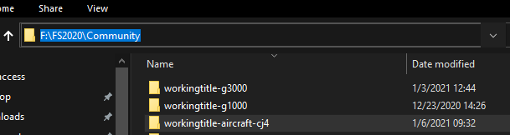

*(Your installation path may differ.)*

| **NOTE**: The Installation will not add a new aircraft. This is a modification of the default Cessna CJ4. |
| --- |

## KNOWN ISSUES

### Default Livery Conflicts

The alternate default liveries that now ship with MSFS are not compatible with the CJ4 yet at this time. They currently ship with panel.cfg files that do not include our FADEC module. Please use the standard livery or a known compatible 3rd party or community livery. Compatible liveries can be found in #media in our discord or here:

<https://docs.google.com/spreadsheets/d/1-FZh5ZNXsSoHZFRcvkQwa-PHuBSk1QRTt7eYvx7Q4xU/edit?usp=sharing>

### Flight Plan Synchronization Between the Game and FMS

* You can still "file" your flight plan to ATC by entering it in the world map of MSFS and it will remain visible to ATC/VFR.
* To load the plan into the FMS you can either enter it manually or use the *FPLN RECALL (GAME/SB)* option in *IDX -> PAGE2 -> ROUTE MENU*
* Due to the increased accuracy and capabilities of the FMC managed flight plan, you may find that the sync to the game does not always work as expected or does not reflect the FMC flight plan.

### Other Known Issues

* Some external applications that use the GPS/Flight plan SimVars may not function correctly or as expected.
* Loading and saving flights can have bad results.
* Custom liveries can render FADEC inoperative if they ship with a panel.cfg. You must uninstall them or remove their panel.cfg from the livery folder. This is a limitation of the Asobo livery system.
* Autopilot modes cannot be triggered via keybindings or controllers and must currently be triggered in the cockpit with the mouse.
* TOD sometimes will flash on the PFD during an approach.
* Sometimes a heading to altitude instruction on takeoff will display further than the first RNAV fix on an RNAV departure procedure; in these cases the workaround is to cross-check the DP chart and remove the erroneous waypoint either by deleting the heading to altitude fix or dropping the first RNAV fix onto the magenta line in the LEGS page.
* Due to sim autopilot bank rate limitations, the aircraft may overshoot on certain RNP approaches with tight turns. If you encounter this, we recommend hand-flying the approach with the given lateral and vertical guidance.
* The FMS now builds turn anticipation into direct-to course projection. However, you will still encounter some overshoot beyond 90 or so degrees.
* If for whatever reason, you find that VNAV is not behaving as expected, try and turn it off and on again.
* FADEC CRU mode producing higher N1 at high altitudes than CLB mode - Current FADEC limitation.
* IDENT is currently not available for use on VATSIM or IVAO and must come from pilot client (vPilot or equivalent).
* Autopilot modes cannot be triggered via key bindings or controllers and must currently be triggered in the cockpit with the mouse. External binding applications are adding support for LVars and HEvents. Used SimVars are documented in our [Guide on SimVars](https://packages.workingtitle.aero/cj4/guides//cj4/guides/simvars).

For a more complete list of issues being tracked, please visit our GitHub page: [**https://github.com/Working-Title-MSFS-Mods/fspackages/issues**](https://github.com/Working-Title-MSFS-Mods/fspackages/issues)

### Common Fixes

* **Blank Cockpit with no interior** - Check that you are using the latest version of the Mod found at the top. 0.8.2 or earlier is no longer compatible with the current version of MSFS.
* **Throttle doesn’t move but still functions** - Incompatible livery, see above. Use default livery or one from the known list of working ones in #Media discord channel.  
  And check the “MyDocuments” folder on your pc for a stray *SimConnect.cfg*
* **Engines not starting/shutting off randomly** - Rogue mixture axis bound to hardware - check hardware binds.

## 

## 

## 

## 

## ~~SIMBRIEF~~

**~~Configuring the FMC for Simbrief import.~~**

* ~~Use Simbrief to create a flight plan and generate an OFP~~
* ~~The Simbrief BETA Airframe can be found here:~~ [**~~https://bit.ly/3lFM0d3~~**](https://bit.ly/3lFM0d3)
* ~~Make note of your~~ **~~PILOT ID~~**~~, a 5 or 6 digit number (XXXXXX), which appears in the Optional Entries section of the flight planning (Dispatch Options) page.~~

~~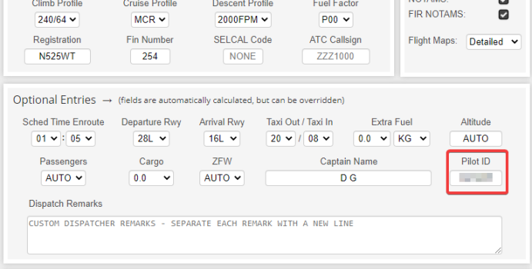~~

* ~~Load up the aircraft (you can start at a gate, parking position, anywhere you like).~~
* ~~On the FMC, press~~ **~~IDX~~** ~~to open the INDEX page and go to PAGE 2.~~
* ~~Click to open~~ **~~MOD SET.~~**
* ~~Enter your PILOT ID in the scratchpad (~~**~~should be a 5 or 6-digit number~~**~~).~~
* ~~Press the~~ **~~LSK L2~~** ~~button next to the - - - - - - under SIMBRIEF PILOT ID header - this will turn~~ **~~GREEN~~** ~~if it has been accepted - this is now stored in the simulator and will remain persistent even after simulator restarts (you can skip these initial steps for future imports)~~
* ~~Press~~ **~~IDX~~** ~~to open the INDEX page and go to PAGE 2~~
* ~~Click to open~~ **~~ROUTE MENU~~**
* ~~You should see~~ **~~FPLN RECALL~~****~~(SB)~~** ~~highlighted with your PILOT ID under it in~~ **~~GREEN~~**~~.~~
* ~~Click~~ **~~FPLN RECALL (SB)~~** ~~and your flight plan should import; you will be returned to the~~ **~~FPLN~~** ~~PAGE and will be prompted to hit~~ **~~EXEC~~** ~~to finalize the new flight plan~~

**THIS PAGE HAS BEEN INTENTIONALLY LEFT BLANK**

# 2 - LIMITATIONS

The real CJ4 is only rated for operation on ‘paved surfaces’ (runways), however because of the magic of MSFS, feel free to take off and land anywhere you’d like.

## WEIGHT LIMITS

| Maximum Ramp Weight | 17,230lbs |
| --- | --- |
| Maximum Takeoff Weight (MTOW) | 17,110lbs |
| Maximum Landing Weight (MLDW) | 15,660lbs |
| Zero Fuel Weight (ZFW) | 12,500lbs |

## SPEED LIMITS

| MMO (Above 27,884 feet) | Mach 0.77 (indicated) |
| --- | --- |
| VMO (Between 8000 and 27,884 feet) | 305 KIAS |
| VMN (Below 8000 feet) | 260 KIAS |

Maximum Flap Extended Speed - VFE

| 15 Degrees | 200 KIAS |
| --- | --- |
| 35 Degrees | 160 KIAS |

| Maximum landing gear extended speed - VLE | 200 KIAS |
| --- | --- |
| Minimum speed for sustained icing conditions | 160 KIAS |

## WIND LIMITS

| Maximum landing tailwind | 10 KTS |
| --- | --- |
| Maximum demonstrated crosswind | 25 KTS |

## ENGINE LIMITS

| Maximum N1(%) | 104.4% |
| --- | --- |
| Maximum sustained TO power | 5 minutes total per engine start/stop cycle |

## APPROACH TYPES

The CJ4 is certified for CAT I ILS or LPV/WAAS approaches with no less than 200’ AGL minimums. BARO minimums must be used for all CAT I, LPV and other approaches. RNP AR approaches are **not authorized**.

**THIS PAGE HAS BEEN INTENTIONALLY LEFT BLANK**

# 3 - NORMAL PROCEDURES

## ~~CHECKLISTS~~

~~Full checklists have been implemented on the MFD – you can access them from the~~ **~~UPR MENU~~** ~~or the~~ **~~CKLIST~~** ~~button on the panel below the left MFD. This SOP is not a replacement for the checklists.~~

~~A PDF Version of the checklist is available here courtesy of Discord user SeeBread:~~ [**~~https://cdn.discordapp.com/attachments/767761280366805022/792995990659399700/WT_CJ4_Checklist.pdf~~**](https://cdn.discordapp.com/attachments/767761280366805022/792995990659399700/WT_CJ4_Checklist.pdf)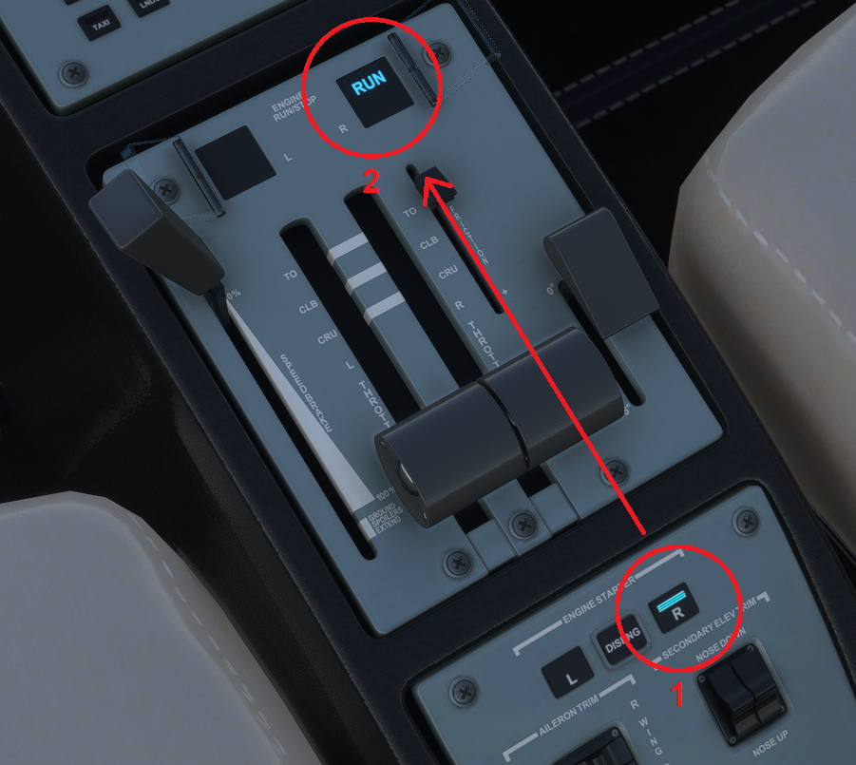

## ENGINE START

Starting the engines in the CJ4 is a very simple task. Once the BATTERY is on, it requires no other configuration other than simply pressing the L or R ENGINE STARTER button and then without delay, pressing the L or R ENGINE RUN/STOP switch. Once the ENGINE STARTER button has been pressed, the **STOP** indication under the button guard will disappear and once pressed, will switch to **RUN** indicating that the start process has been initiated.

Monitor the MFD for the following indications:

1. **STARTER** indication on the MFD.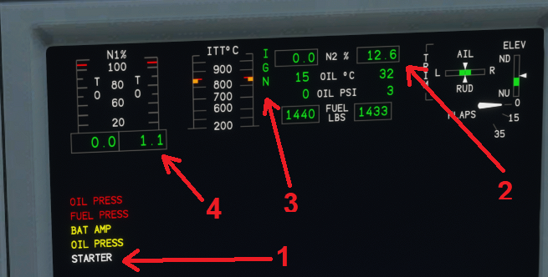
2. N2 will begin to rise followed slowly by N1
3. At 12% N2, **IGN** will be displayed next to the ITT indicator.
4. After the ignition sequence begins, N1 and ITT will continue to rise before stabilizing at approx. 25% N1, 600°C ITT and the **IGN** indication will extinguish.

Repeat the process for the other engine.

## 

## TAKEOFF AND LANDING V-SPEEDS

The **FMS PERF** pages provide for takeoff and landing V-Speeds, and these can be pushed to the PFD from the FMS on the relevant pages. A departure and arrival runway must be selected through the **DEP/ARR** button on the FMS prior to attempting to use the respective **PERF** page in the FMS.

These V-Speeds are influenced by flap settings, weight and other parameters that can be set in the FMS. VAPP and VREF do not account for any gust or wind factor on approach. If you are landing in windy, gusty or icing conditions, you can add a safety margin to your VAPP and VREF speeds by pressing the **REFS MENU** above the PFD and manually adjusting any of the V- Speeds.

V-Speeds set by the FMS will be colored **MAGENTA** and those manually set or adjusted will be **CYAN** on the PFD.

A standard wind/gust factor addition of half the headwind component plus the gust value is recommended. **DO NOT** add more than 15 kts to the VAPP speed.

| **NOTE**: Be sure to complete the **PERF INIT** page and set up the weights according to how the aircraft is loaded, otherwise your V-Speeds will be inaccurate - *these do not calculate based on sim weights, but rather what the pilot inputs* - *just like the real aircraft!* |
| --- |

## TAKEOFF PROCEDURE

The recommended takeoff procedure is in addition to completing the checklists.

Takeoff can be performed from either a rolling takeoff, without stopping after entering the runway, or as a static takeoff. For a static takeoff, hold the brakes and release them as the engine begins to spool up. Performance is generally not affected whether performing a static or rolling takeoff. For shorter airstrips, a static takeoff is preferred to ensure enough runway remains within the safety margins.

* (When entering runway) Enable **TOGA** - This will command a 10 degree pitch up attitude on the Flight Director and a path straight ahead. The FMA (scoreboard) will show **TO TO**. 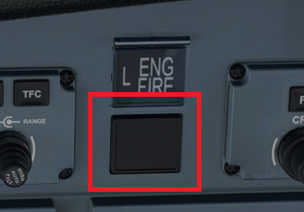

**NOTE**: The TOGA button is normally found on the sides of the throttle but is currently INOP in the sim. The workaround is a shortcut we mapped to the FIRE BOTTLE directly under L ENG FIRE button - click to enable it. It can also be bound to a key or hardware switch.



* Advance throttle to **TO** (Take Off) detent (full forward).
* After rotation, increase pitch to 10° nose up and trim accordingly.
* Retract gear and set FLAPS 0 after accelerating through V2 + 10.
* Engage the Yaw Damper (**YD**) after retracting flaps.
* Passing 1,000’ AGL, reduce power to **CLB** setting detent (FADEC will automatically manage power during the entire climb).
* Set target initial climb altitude with the **ALT** knob on the FGP (Flight Guidance Panel).
* Engage **FLC** mode and set target speed to 240 KIAS (AP will automatically switch to M0.64 when passing roughly FL300).
* Engage **HDG** or **NAV** mode depending on departure procedure.

Manage pitch angle to accelerate smoothly and when passing about 200 KIAS, you can enable the Autopilot (**AP**) – this is a personal choice, some will prefer to fly manually to 240 KIAS and then engage the **AP** to avoid having **FLC** pitch down for acceleration, others may wish to turn things over to the **AP** sooner. Anything above 200 kts should work fine for **FLC**, the aircraft will reduce climb to reach 240 KIAS, then pitch up to maintain that speed through the climb.

**NOTE:** Minimum Autopilot (AP) or Yaw Damper (YD) engagement altitude after takeoff or go around is 300’ AGL.

**NOTE:** Real-world procedures limit FADEC in **TO** Mode to 5 minutes maximum *per flight.*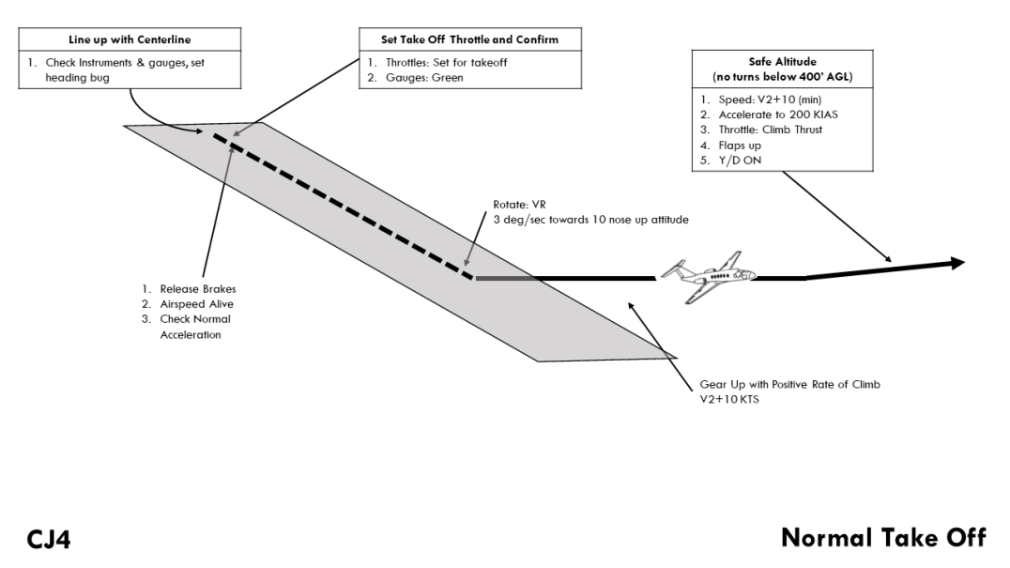

## (All Pattern Images Courtesy of mabrodb)

## 

## CLIMB PROCEDURE

Climb should be conducted using **FLC** at **240 KIAS/M0.64** - monitor Mach and IAS and after the crossover, maintain M0.64 (switched automatically). The newly implemented FADEC will manage climb power all the way to cruising altitude. You can expect climb rates in the 3,000-5,000 fpm range below 20,000’ and in the 2,000-3,000 fpm range in the 20,000s. In the FL300s, you can expect climb rate to be around 2,000 fpm decreasing with altitude.

## CRUISE PROCEDURE

Upon reaching cruise altitude you can use the throttle to set power to maintain your desired cruise speed, up to MMO/VMO. In the real aircraft, any throttle setting besides **TO** can be used during cruise. There is no detent for CRU, nor does the CJ4 have auto-throttle -- speeds are managed by the pilot. Monitor fuel flow, range and time to reserve on the FMS **PERF** pages.

## DESCENT PROCEDURE

Descent can be conducted on a 3° flight path; this rate of descent can be estimated by multiplying your ground speed by 5, so at ground speed of 450 kts, a rate of descent of 2,250 fpm would give you ~3° descent. You can elect to descend faster, rates of up to 3000 fpm can be used, especially from cruise altitude.

Top Of Descent (TOD) can be calculated roughly for a 3° flight path by taking the difference between your current altitude and landing altitude, multiplying by 3 and dividing by 1000. So, for example, if you’re cruising at 45,000’ and you’re landing in Denver at about 5,000’, then 45000-5000 = 40000; 40000 X 3 = 120000; 120000/1000 = 120. So start descent 120 NM from Denver.

You can elect to use either FLC, VS or VNAV to manage your descent; VS mode will allow you to more accurately target your descent to arrive at altitude constraints, but you need to constantly monitor your power settings and speed. Alternatively you can use FLC to descend by setting a target speed not above Vne/Mmo and then adjusting your power settings to achieve the target rate of descent. VNAV is covered at the end of this guide under AUTOPILOT OPERATION.

Allow time to slow to 250 KIAS by 10,000’ and it is not recommended to exceed a 3° descent below 250 KIAS. 3° at 250 KIAS is 1,250 fpm.

## 

## 

## APPROACH AND LANDING

Program your approach into the FMS after checking destination weather and, when appropriate, confirming the expected approach from ATC. Attempting to change the approach after an approach has been initiated can result in FMS anomalies and will force you to return to the IAF if flying in LNAV mode.

If flying an ILS approach, use the FMS IDX -> NEXT PAGE -> ARR DATA page to check inbound ILS course and ILS frequency and then confirm the proper ILS frequency is set in the TUN page for NAV1.

Use the PERF FMS page to access the APPROACH REFS page; you will need to enter arrival weather data, such as wind, temperature (degrees C), and altimeter setting (inHG), as well as have an approach and runway selected in DEP/ARR in order for the APPROACH REFS page to work. Once page 1 is completed, hit NEXT to get page 2, where you can send your Vref and Vapp speeds to the PFD. Use the PFD REFS MENU to make any manual adjustments to the approach speeds to account for wind or gust factor.

Slow to 200 KIAS or less prior to initiating the approach and slow to no greater than 160 kts by FAF. For a precision approach it is recommended to be at Vapp by the FAF.

The Autopilot must be disengaged no lower than 200’ AGL and the yaw damper off before touchdown. When crossing the runway threshold, pull the power smoothly back to idle and initiate flare and landing. Upon landing, deploy the spoilers and use brakes as needed to slow the aircraft. The CJ4 does not have thrust reversers.

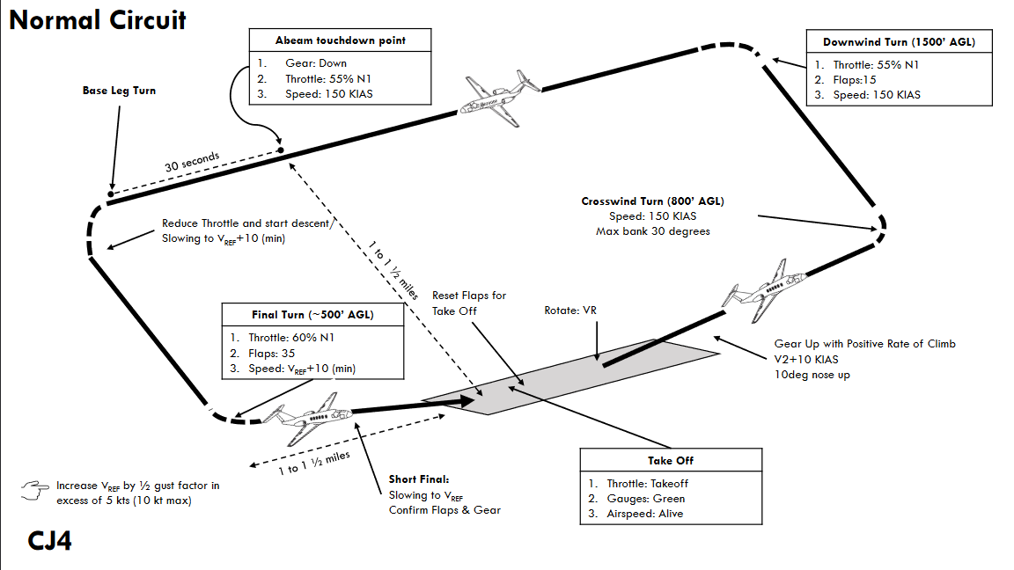

## 

## 

## 

## 

## 

## 

## 

## 

## 

## 

## 

## MISSED APPROACH/GO-AROUND

Missed approaches can now be activated in the CJ4. A missed approach will automatically be loaded in the FMS if an instrument approach procedure is also loaded. When the **TOGA** button is pressed, the flight director (FD) will be set and locked to fly the current heading.

The procedure is as follows:

1. Press **TOGA** Button (See **PAGE 3-2** for where this button is and how to change the keybind).
2. Thrust levers to **TO** (Take Off).
3. Set Flaps 15.
4. At Positive rate of climb - Gear up
5. Set FLC 200kts (This speed is your discretion but there isn’t much reason to be going faster than 200)
6. At VAPP+10 - Flaps 0
7. Select **NAV** button on DCP to set source to FMS again (Procedure subject to future changes).
8. Press NAV on FGP to select LNAV (Procedure subject to future changes).
9. Throttles - As necessary.

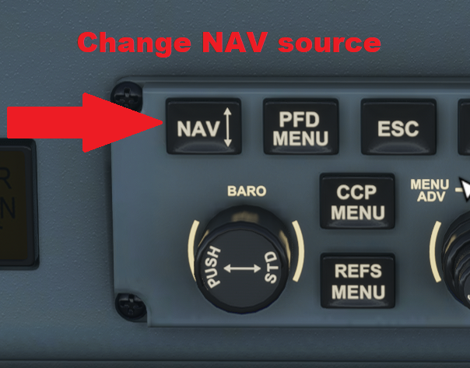

**THIS PAGE HAS BEEN INTENTIONALLY LEFT BLANK**

# 4 - WEIGHT AND BALANCE

| Maximum Takeoff Weight (MTOW) | 17,110lbs / 7,761kg |
| --- | --- |
| Basic Operating Weight (BOW) | 10,280lbs / 4,663kg |
| Useful Load | 6,830lbs / 2,894kg |
| Baggage Capacity | 1,040lbs / 472kg |
| Fuel Capacity | 5,762lbs / 2,614kg |

The current, revised flight model provides seating for 7 passengers and 2 crew members. The lavatory seat is not able to be loaded at this time.

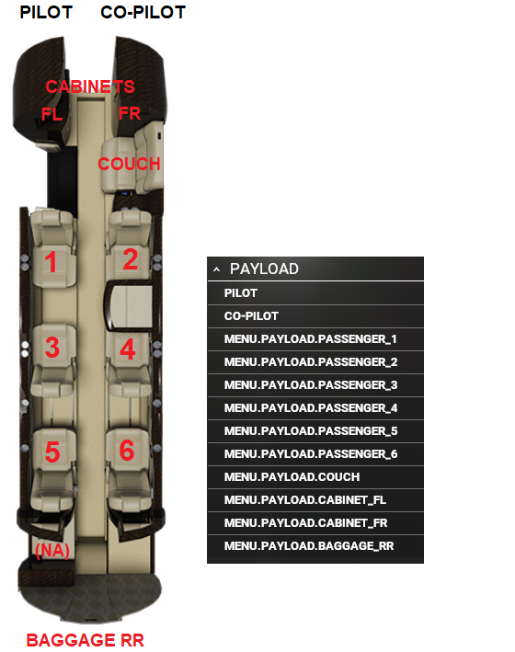

| **NOTE:** Our current model does NOT include a pilot in the BOW (Basic Operating Weight)/Empty Weight. They must be included in the passenger total in PERF INIT to get the correct Gross Weight (GWT). |
| --- |

# 

# 

# 

**THIS PAGE HAS BEEN INTENTIONALLY LEFT BLANK**

# 5 - FLIGHT MANAGEMENT SYSTEM

The CJ4 features a Collins FMS-3000(v4.0) as part of the Pro Line 21 Suite of avionics. Not all functions are currently available in MSFS at the moment. Some are just not implemented and may be at a later date, and others are just not possible or relevant in some cases. They will be grayed out in the FMS if they currently have no function or the key may not be active.

These sections on the FMS will cover many of the basic operations but will not cover every detail, especially if it is not relevant to the simulation environment. It is an ongoing, work in progress.

## CDU DISPLAY OVERVIEW

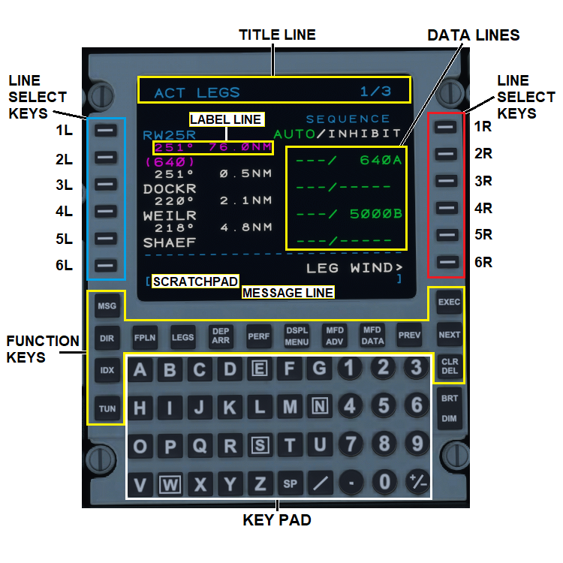

## ~~MOD SET~~

~~This page on the FMS contains a number of user defined settings which will persist after each load (when the SIM is exited correctly through the menus).~~

~~The~~ **~~MOD SET~~** ~~can be accessed via~~ **~~IDX~~**~~>~~**~~NEXT~~**~~>~~**~~MOD SET~~**

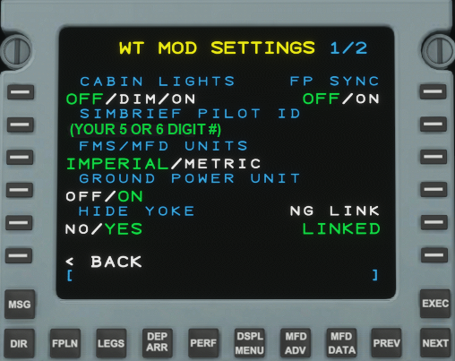

* **~~CABIN LIGHTS~~** ~~- Turns the rear cabin lights to either~~ **~~OFF~~**~~,~~ **~~DIM,~~** ~~or~~ **~~ON~~** ~~state.~~
* **~~SIMBRIEF PILOT ID~~** ~~- Input user PILOT ID for Simbrief import - MUST BE A 5 or 6-DIGIT NUMBER~~
* **~~FMS/MFD UNITS~~** ~~- Toggles the FMS display and MFD between IMPERIAL and METRIC units.~~

| **~~NOTE: THIS DOES NOT CHANGE THE PFD UNITS~~**~~. That must be done through the~~ **~~PFD MENU~~** ~~(Section 7-6).~~ |
| --- |

* **~~GROUND POWER UNIT~~** ~~- Applies ground power to the aircraft -~~ **~~WHERE AVAILABLE~~**~~. To receive power, you must be at a designated parking spot within MSFS that has ground power available to it.~~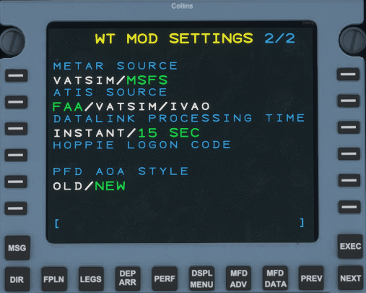
* **~~HIDE YOKE~~** ~~- Applies a persistent setting to show or hide the yokes in the cockpit.~~
* **~~FP SYNC~~** ~~- Synchronizes to the MSFS flight plan from your FMS flight plan when toggled~~ **~~ON~~** ~~for use with in-game ATC. The MSFS planner is fragile so this may lead to undesirable consequences.~~
* **~~NAVIGRAPH~~** ~~- Links Navigraph Chart subscription for~~ ~~E-Chart~~ ~~access on MFD. To link a chart subscription, click on LSK 5R next to NOT LINKED to begin the process. A web browser to Navigraph will then open up asking for the WT CJ4 to access a token on Navigraph’s servers. You should only need to repeat this process once.~~

| **~~NOTE~~**  ~~Working Title at no time has any access to personal information in this exchange. It is an~~ *~~OAuth Device Authorization Flow~~* ~~for which the CJ4 simply asks Navigraph for an access/refresh token once they verify the account through the weblink. All of this is stored locally on the user’s machine.~~ |
| --- |

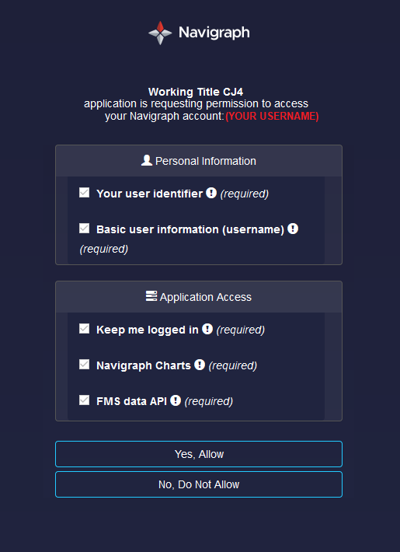

~~Click “Yes, Allow” to receive an access token from Navigraph servers.~~

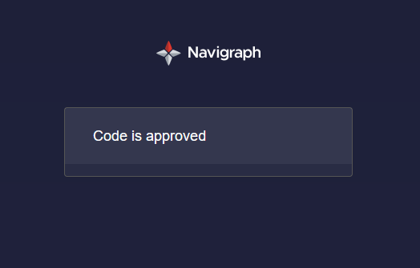

~~Once you see the above message “Code is approved,” you can close the browser window and switch back to MSFS. NAVIGRAPH should now show LINKED in green underneath it allowing for CHART access on the MFD.~~

* **~~METAR SOURCE~~** ~~- Selects the source of METAR retrieval to either VATSIM or MS Flight Simulator (MSFS).~~
* **~~ATIS SOURCE~~** ~~- Selects the datasource for ATIS retrieval to either the FAA, VATSIM, or IVAO.~~
* **~~DATALINK PROCESSING TIME~~** ~~- Toggles the time it takes for the datalink to process a METAR or ATIS request between INSTANT or 15 SEC (more realistic).~~

## **~~HOPPIE LOGON CODE~~** ~~-~~ **~~NOT IMPLEMENTED - WIP~~**

* **~~PFD AOA STYLE~~** ~~- Toggles the PFD AoA indicator style to display between newer and older software revisions.~~

## 

## 

## 

## 

## 

## 

## 

## 

## 

## 

## STATUS

When the FMS first powers on, you will be presented with this **STATUS** screen. A message will appear on the message line asking to **INITIALIZE POSITION** so that the aircraft can determine where it is.

* **ACTIVE DATA BASE** - Displays the active navigation database.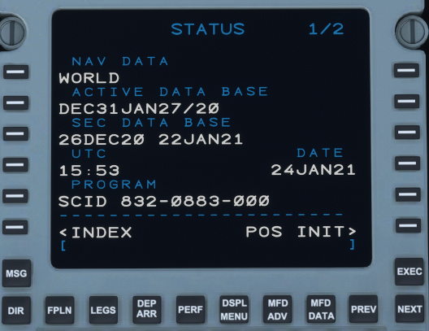
* **SEC DATA BASE** - Displays the secondary navigation database.

| **NOTE:** Valid database dates with Navigraph updates should now show correctly. |
| --- |

* **UTC** - Displays current UTC time.
* **DATE** - Displays current date.

## 

## POS INIT

The **POS INIT** display allows you to initialize where the aircraft is currently. An **INITIALIZE POSITION** message will appear in the message line on first load until the position is set. To set the position, press LSK 4R to copy the GNSS (GPS) position of the aircraft into the **SET POS** line. The GNSS position will then automatically populate the SET POS line along with a COMPLETED message above it. The position of the aircraft should now be initialized. Many features of this page are not yet functional as the sim knows the precise position of the aircraft at all times.

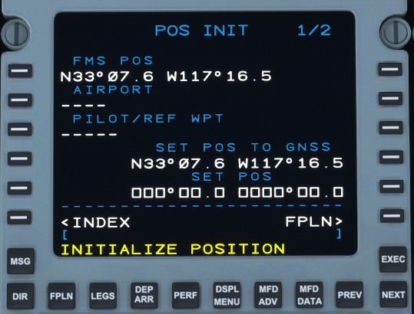

* **FMS POS** - Displays coordinates of the aircraft’s current FMS position.
* **AIRPORT** - Displays the airport reference position once entered in ORIGIN on the FPLN page.
* **PILOT REF/WPT** - Allows for a reference airport to be entered.
* **SET POS TO GNSS** - Displays current GPS position.
* **SET POS** - Allows the user to set the current position of the aircraft - input to this field currently has no actual geographic effect on aircraft position within the SIM other than satisfying the requirement for the FMS that it be entered.

## PERF MENU

PERF MENU displays all performance menu options available on the FMS-3000. A more detailed description of each page is outlined in the sections below.

* **<PERF INIT** - Contains Performance Initialization. (*See* *PERF INIT*)

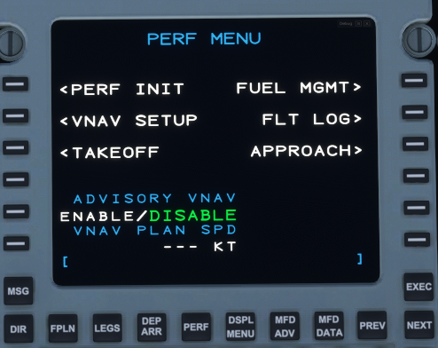

* **<VNAV SETUP** - Contains set up for VNAV functions such as VNAV CLIMB, VNAV CRUISE and VNAV DESCENT.
  + VNAV CLIMB - you can specify the VNAV climb speed and crossover mach value; FLC will use this mach value to manage the crossover during a climb and switch to mach mode when reaching that mach value.
  + VNAV DESCENT - you can specify the VNAV descent speed and crossover ias value; FLC will use this ias value to manage the crossover during a descent and switch to ias mode when reaching that ias value.
* **<TAKEOFF** - Contains TAKEOFF initialization data for determining V-Speeds and distances. (*See* *TAKEOFF*).
* **FUEL MGMT>** - Displays Fuel Management data such as current fuel, range, time to reserve and fuel flow, fuel used, and several other parameters.
* **FLT LOG>** - Displays a Flight Log which contains takeoff and landing times, enroute time, distances flown, fuel used, and airspeeds.
* **APPROACH>** - Contains APPROACH initialization for landing speeds and distances. (*See* *APPROACH*)
* **ADVISORY VNAV** - **NOT IMPLEMENTED**
* **VNAV PLAN SPD** - **NOT IMPLEMENTED**

### 

### 

### PERF INIT

PERF INIT is short for Performance Initialization. This is where initial aircraft performance is input into the FMS for calculating takeoff and landing performance data such as v-speeds and required runway lengths. 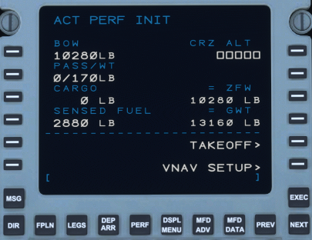

* **BOW** - Basic Operating Weight. This is the weight of the aircraft WITHOUT passengers, baggage, or fuel.
* **PASS/WT** - Number of passengers (PLUS both pilots, if used, at this time) and their weight. To change passenger weight, enter the number of passengers then a / followed by their weights. (ie: 4, 6/180, /165)
* **CARGO** - Weight of all cargo and baggage. This includes the cabinets and baggage from the load manager.
* **SENSED FUEL** - The current sensed fuel amount in the aircraft. If the amount is changed, you will need to re-access the PERF INIT page before it will refresh.
* **CRZ ALT** - Planned cruising altitude. Can be entered as a whole number (20000), FLXX (FL45) or FXXX (F260).
* **ZFW** - Zero Fuel Weight. This is the weight of the aircraft WITH passengers and cargo - excludes fuel. You can enter a ZFW independent of filling out the information in the left-hand column if it is calculated elsewhere. There FMS does not care about CG. It assumes that the aircraft is loaded within the limits and only uses the gross weights to perform v-speed and required length calculations. Hitting CLR on ZFW will restore the values for BOW, PASS/WT and CARGO.
* **GWT** - Gross Weight. This is the present, total weight of the aircraft with passengers, cargo, and fuel. Can also be manually entered by the pilot. Doing so will blank out all other entered values for passengers and cargo.

### TAKEOFF

The TAKEOFF REF page is where the second part of performance calculations receives variables in order to determine v-speeds and takeoff lengths.

PAGE 1/3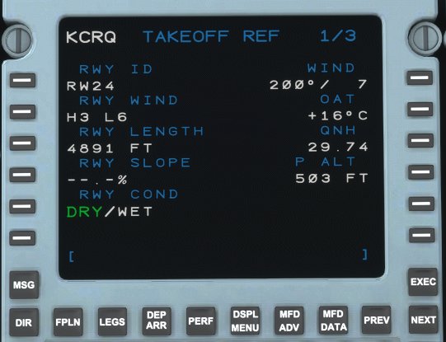

* **RWY ID** - Departure runway as selected from the DEP page. - *Required for v-speed calculation.*  (*See* *DEP ARR*)
* **RWY WIND** - Runway wind. Will automatically display the headwind and crosswind components as derived from **WIND** in LSK 1R(ie. **H4 L1**)**.** *(See* *LIMITATIONS* *for maximum component values)*
* **RWY LENGTH** - Runway length of the selected departing runway based off the **RWY ID**.
* **RWY SLOPE** - Runway Slope. Maximum valid range -2% to +2%. Slopes can also be entered as UX.X (up) or DX.X (down). (ie. U1.6 = +1.6, D.5 = -0.5)
* **RWY COND** - Runway condition. Allows for the selection between DRY/WET. A WET increases the takeoff distance required.
* **WIND** - Winds should be input from a magnetic reporting source such as audible ASOS or ATIS. Must be input as a 1-3 digit direction followed by a speed in knots (ie. **240/6, 5/10**). When leaving this field blank, the FMS calculates the winds as calm.
* **OAT** - Outside Air Temperature in degrees Celsius *- Required for v-speed calculation.*
* **QNH** - Current altimeter reading. QNH can be entered without the decimal (ie. 3001) *- Required for v-speed calculation.*
* **P ALT** - Pressure Altitude. Automatically calculated based on elevation, temperature and pressure.

PAGE 2/3

* **A/I** - Anti-Ice. Toggles A/I engine performance degradation OFF or ON. A/I ON Slightly increases **TOFL**.

| **NOTE**: The CJ4 does not currently model degraded engine performance when anti-ice is on. |
| --- |

* **T/O FLAPS** - Take off flaps. Selectable between 0 and 15. Flaps 15 is almost always used for take off. Flaps 0 is used when the aircraft is heavy and/or the departure location is hot and high.
* **TOW/GWT/MTOW** - Displays Takeoff Weight (TOW), Gross Weight (GWT), and Maximum Takeoff Off Weight (MTOW).Takeoff weight is currently GWT-100.
* **TOFL/ RWXX** - Displays the required takeoff field length (TOFL) and the length of the set takeoff runway. TOFL is calculated from the start of the take off roll until the aircraft reaches 35’ above the runway.
* **V1** - Speed after which a take off should not be aborted.
* **VR** - Rotation Speed.
* **V2** - Safe speed for single-engine operation following an engine failure.
* **VT** - Single-engine enroute climb speed. Always 140 KIAS in the CJ4.

Once all performance data has been input, v-speeds should automatically appear in the right-hand column. To get them to display on the PFD, press the **SEND** button. A message IN PROGRESS will appear followed by COMPLETE once the process has finished and they will appear in MAGENTA on the PFD below the speed tape.

PAGE 3/3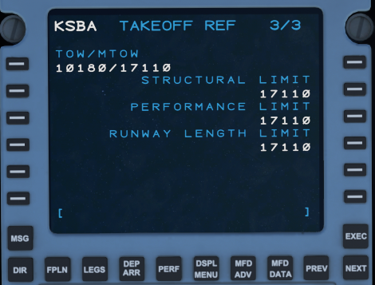

Displays additional takeoff weight and limits.

### 

### 

### 

### APPROACH

The APPROACH page within the PERF MENU contains input fields for computing landing speeds (VREF, VAPP), and landing distances. The page is arranged and operates in a similar manner to the TAKEOFF page.

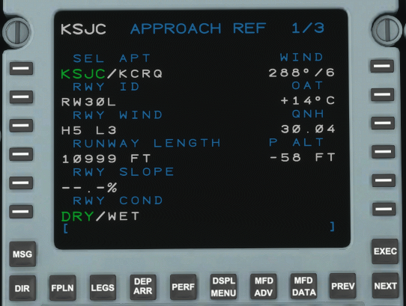

PAGE 1/3

* **SEL APT** - Select Airport. Allows users to set which airport they are selecting approach data for - *Not currently selectable, will default to DESTINATION.*
* **RWY ID** - Arrival runway as selected from the ARR page. - *Required for v-speed calculation.* (*See* *DEP ARR*)
* **RWY WIND** - Runway wind. Will automatically display the headwind and crosswind components as derived from **WIND** in LSK 1R(ie. **H4 L1**)**. (***See* *LIMITATIONS* *for maximum component values.)*
* **RWY LENGTH** - Runway length of the selected arriving runway based on the **RWY ID**.
* **RWY SLOPE** - Runway Slope. Maximum valid range -2% to +2%. Slopes can also be entered as UX.X (up) or DX.X (down). (ie. U1.6 = +1.6, D.5 = -0.5)
* **RWY COND** - Runway condition. Allows for the selection between DRY/WET. A WET runway leads to a longer landing distance required.
* **WIND** - Winds should be input from a magnetic reporting source such as audible ASOS or ATIS. Must be input as a 1-3 digit direction followed by a speed in knots (ie. **240/6, 5/10**). When leaving this field blank, the FMS calculates the winds as calm.
* **OAT** - Outside Air Temperature in degrees Celsius at destination. *- Required for v-speed calculation.*
* **QNH** - Current altimeter reading at destination. QNH can be entered without the decimal (ie. 3001) - *Required for v-speed calculation.*
* **P ALT** - Pressure Altitude. Automatically calculated based on elevation, temperature and pressure.

PAGE 2/3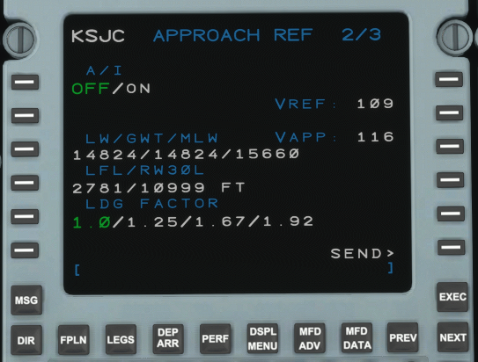

* **A/I** - Anti-Ice. Toggles A/I OFF or ON. Slightly increases **LFL**.

| **NOTE**: The CJ4 does not currently model degraded engine performance when anti-ice is on. |
| --- |

* **LW/GWT/MLW** - Displays Landing Weight (LW), Gross Weight (GWT), and Maximum Landing Weight (MLW).
* **LFL/ RWXX** - Displays the required Landing Field Length (LFL) and selected available runway length.
* **LDG FACTOR** - Toggles the ability to add additional LFL calculations for emergencies.
* **VREF** - Reference Speed. 1.3 x the stall speed in landing configuration (VSO) for a given weight.
* **VAPP** - Approach Speed. Always computed as VREF +7kts. Does not compute based on winds. Any added wind factor (½ steady + gust) must be manually entered on the PFD, not to exceed 15 knots.

PAGE 3/3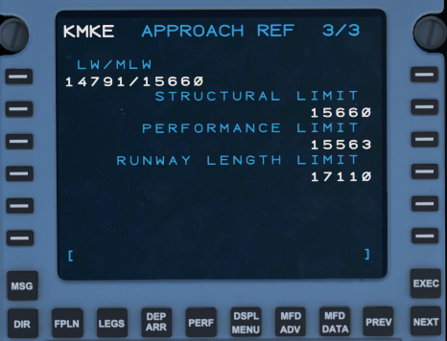

Displays additional landing weight and limits.

## 

## 

## 

## 

## 

## FPLN (ACT FPLN)

The ACT FLPN page is where you begin when building out your flight plan. It is advisable to not program a STAR or approach until the enroute portion of the plan has been completed as this may prevent the entering of airways.

The flight plan in this example is: *KCRQ/24 PADRZ2.CHKNN LAX J1 AVE.ROBIE5 KSJC and ILS30L vectors-to-final.*

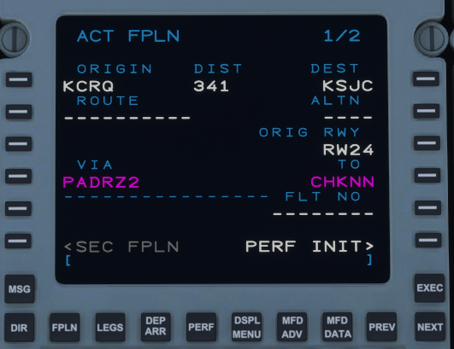

* **ORIGIN** - Origin airport in 3 or 4 letter ICAO code. This cannot be modified once airborne. Modifying the ORIGIN airport on the ground will clear the current flight plan if executed.
* **DIST** - Direct distance from ORIGIN to DEST.
* **DEST** - Destination airport in 3 or 4 letter ICAO. This can be modified at any time.

| **NOTE:** An airport inserted into an origin or destination may report as NOT IN DATABASE even if it is valid. If this occurs, you can re-press the corresponding LSK where the error was reported and it should work on the second press, or you may clear the error and retry. |
| --- |

* **ROUTE** - **NOT IMPLEMENTED**
* **ALTN** - **NOT IMPLEMENTED**
* **ORIG RWY** - Displays the selected departure runway. Can also be manually input by the user or from the DEPART page. (*See* *DEPART*)
* **VIA** - If a SID is programmed from the DEP/ARR page, it will appear here. Otherwise, it will always be DIRECT when a waypoint is manually entered into TO.

| **RULE**: VIA will not take user input on page 1only**.** Airways must be entered on page 2 or higher. |
| --- |

* **TO** - If a SID is programmed, the exit-point of the SID will appear here on page 1. If not, input the first waypoint after the departure runway.
* **FLT NO** - Allows user to enter a flight number.
* **<SEC FPLN** - **NOT IMPLEMENTED**
* **VIA** (PAGE 2+) - After page 1 of the ACT FPLN page, **VIA**, is used by airways, STARS, or approaches to connect points, otherwise they are DIRECT. You must enter the airway *first* using the left LSKsand then connect it to an exit using the opposite right LSK. Airways on page 2 will connect from a SID on page 1 if they are valid for that airway.
* **TO** (PAGE 2+) - Similar to **VIA**, waypoints from the scratchpad are entered under the **TO** column using the right LSKs. They must be defined waypoints such as a VOR, NDB, intersection, or airport. Waypoints entered without an airway will always show as DIRECT under **VIA** and do not require any further action.

| **RULE:** Custom Waypoints will not be accepted inthe ACTFPLN page - they must be entered on the LEGS page. |
| --- |

## DEP ARR

To enter departure runways, SIDs (Standard Instrument Departures)/DPs (Departure Procedures), STARs (Standard Terminal ARrivals), approaches, and arrival runways, press the DEP ARR key. When pressed, the ACT DEPART page for the airport entered in ORIG will be shown if one is selected. To access the INDEX, use LSK 6L, <DEP/ARR INDEX or the DEP ARR function key. When airborne and more than 50nm, or halfway to the destination, pressing the DEP ARR key will automatically bring you to the ACT ARRIVAL page (*This is how the real FMS-3000 operates).*

### DEP/ARR INDEX

The DEP/ARR INDEX allows for the selection of available procedures for the ORIGIN and DEST airports as entered in the ACT FPLN, as well as the SEC (secondary) FPLN.

| **NOTE:** SEC FPLN is currently not implemented. |
| --- |

| **NOTE**: The availability of procedures is limited by what is provided in the stock, NAVBLUE data. This can be enhanced through the addition of Navigraph’s more complete database but the stock data is generally sufficient on its own. |
| --- |

### DEPART

Clicking on <DEP using LSK 1L, will show all available departure procedures as well as available departure runways.

Once on the ACT XXXX DEPART page, select a SID or DP, if desired - not *required*. The SID/DP will appear under **DEPARTURES** in **green** (**PADRZ2**) with the current list of available **TRANS** (transitions) underneath it. To select a transition, click the corresponding left LSK. It will also turn **green** indicating that a transition (**CHKNN**) has been selected. Repeat the process for the desired runway under the **RUNWAYS** selection (**24**). Additional transitions or runways (if available) can be accessed using the NEXT and PREV keys. MOD will appear in the top left corner until EXEC has been pressed.

| **NOTE:** Not all runways are available for a selected SID. Selecting the SID first will show all available runways for that selected SID. Selecting a runway first will show all available SIDs for that selected runway. |
| --- |

### ARRIVAL

Selecting ARR> on the DEP/ARR INDEX will bring you to the ACTXXXX ARRIVALpage. The process for selecting a STAR/approach is very similar to the DEPART page above.



The main difference between DEPART and ARRIVAL is that on the right, instead of just **RUNWAYS**, you will see **APPROACHES** first (if an approach exists at the destination airport), and then **RUNWAYS** below. Use the NEXT and PREV keys to access additional pages (if applicable). A STAR can be selected without an approach or arrival runway as these are not commonly assigned by ATC until the aircraft is within the terminal range (<50nm).

| **NOTE:** Some STARs may not populate all fixes until a runway or approach has been selected, as the final waypoints may vary depending on landing direction. |
| --- |

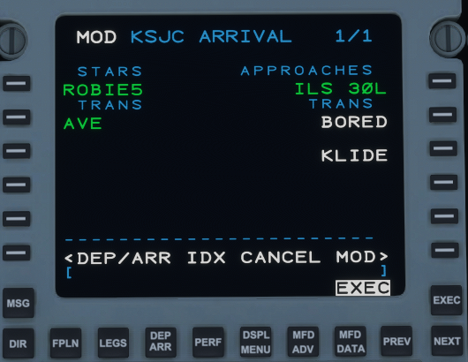

Some approaches may also have transitions. They will appear as **TRANS** under **APPROACHES**. The process for selecting an approach transition is similar to that of a SID or STAR.

#### VISUAL APPROACHES

A visual approach may be used when an instrument approach is not required. To select a visual approach, use the NEXT key to scroll to the end (if necessary) where **RUNWAYS** are listed. These are simply displayed as RW followed by their number and possibly L, R, or C. The selected runway will be shown in **green** under **RUNWAYS** with **RWY EXT** appearing below it. 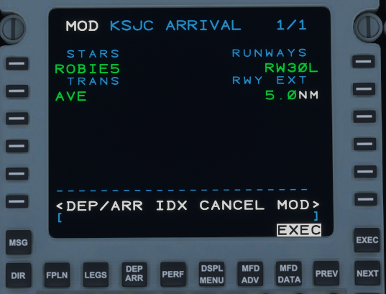

**RWY EXT** allows for the user to input an extension point heading out from the runway for enhanced situational awareness. **RWY EXT** will allow for values between 1 and 25nm with 5nm being default.

| 🛑 A visual approach must not be used in Instrument Meteorological Conditions (IMC) as a substitute for an Instrument Flight Rules (IFR) approach. |
| --- |

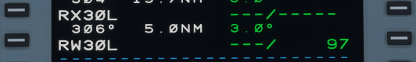

From the LEGS page, a runway extension will appear as “RX.” You can then use this to build custom waypoints for even more situational awareness by creating “downwind,” “base,” or “final” legs. You can also choose to delete the “RX” waypoint and no extension will appear.

## LEGS

After entering your flight plan, check the LEGS page to verify that all waypoints and altitude constraints are correct. (LEG WIND is currently INOP and generally not used on the real CJ4)

### CONSTRAINTS

The ACT LEGSpagelists all the waypoints in a flight plan in the left column. The right column, shown as **- - -/- - - - -**  , lists the speed and altitude constraints for the corresponding waypoint in the left column. These are DATA LINES.

**- - -/** The first 3-dashes *before* the **/** are SPEED constraints. Because the CJ4 does not have an autothrottle, these are for advisory purposes only; the aircraft will not adhere to them.

**/- - - - -** The last 5-dashes *after* the **/** are ALTITUDE constraints and are used by VNAV if enabled.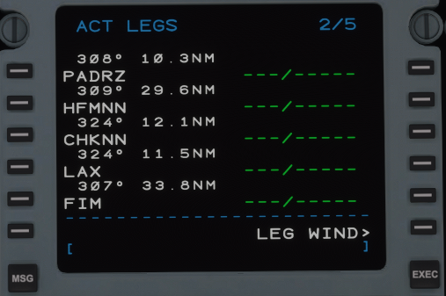

Valid formats for constraints:

* 250/ or 250= Sets speed constraint to 250 KIAS
* 250/18000= Sets a speed constraint of 250 and an altitude constraint of FL180.
* 18000= Sets an altitude constraint of FL180
* FL200= Sets an altitude constraint of FL200
* 18000B= VNAV altitude AT or BELOW FL180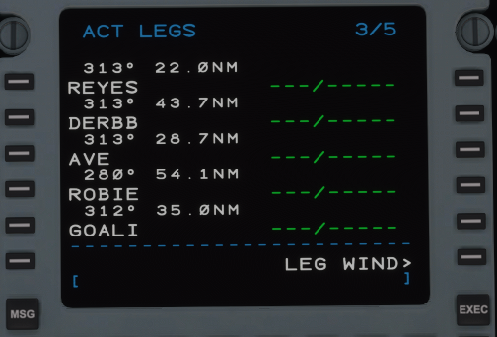
* 9000A= VNAV altitude AT or ABOVE 9000
* 10000A17000B= VNAV altitude AT or ABOVE10000 but AT or BELOW 17000.

| **RULE:** You can enter a speed constraint without a **/** up to 499 before it assumes it’s an altitude. Entering 500 or higher will place it after the **/**. If you like to add an altitude constraint below 500, you must put a **/** before it (**/400**). |
| --- |

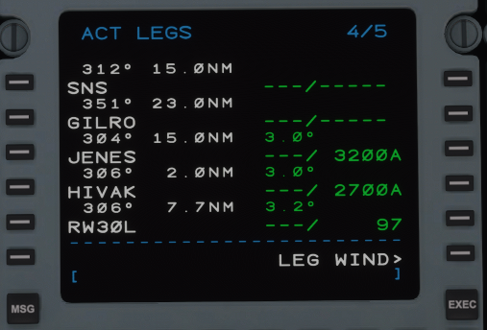

The FMS-3000 does not auto-populate cruise data into the right-hand column. The right side is used only for advisory speeds, and VNAV altitude constraints. The VNAV function will calculate the required descent based on your current altitude. Again, cruise data does NOT need to be entered into the right-hand column.

| **NOTE**: User defined segment VPA not yet implemented. |
| --- |

### SEQUENCING

**SEQUENCE** - AUTO/INHIBIT - When in **AUTO**, the FMS will automatically advance to the next waypoint after passing it, and activate the next leg segment. If toggled with LSK 1R to INHIBIT, the FMS will not advance to the next waypoint in the sequence.

At the end of the flight plan, when the aircraft is direct to the runway fix (**RWXX**), the FMS will automatically switch to **INHIBIT**. Switching the sequence back to AUTO will activate the missed approach if an instrument approach was selected. (*See* *MISSED APPROACH*)

| **NOTE:** If the autopilot remains in FMS NAV mode with **INHIBIT** selected, the aircraft will continuously circle back to the last waypoint it crossed in **magenta**. |
| --- |

Page 1 of ACT LEGS depicts the departure runway and the first several waypoints of our selected SID. LSK 1L and 2L, on page 1, have special properties. Above, we see **RW24**, our departure runway, as the **from** fix. Entering any flight plan waypoint on LSK 1L, this **from** spot, will activate the next leg from that waypoint.

The other special spot is LSK 2L**,** the **to** fix. This always depicts which waypoint the aircraft is currently going *to*. In the above example, the waypoint the aircraft is going direct-to is **(2299)**. As the aircraft passes the **to** fix, it becomes the **from** fix. When a manual direct-to is initiated, the FMS creates a new **from** fix called **(DIR)**. This enables the aircraft to calculate a new course by drawing a line between the two points that the autopilot can follow or intercept. Any valid waypoint, even if it’s not part of the current flightplan, can be inserted into LSK 2L. More information on DIRECT-TO operation is listed in the section below.

### ADDING A WAYPOINT

To add a waypoint to the LEGS page, enter the waypoint (can be a FIX, VOR, NDB, airport or custom waypoint) into the scratchpad. Press the corresponding left LSK where you would like the waypoint to appear.

### LABEL LINES

Above each waypoint are two sets of numbers. The first number is the leg track bearing and the second number is the distance between waypoints. In the last image above, GILRO is 351° from SNS and 23.0NM. Another way to understand it is that to go from GILRO to JENES, you would fly 304° for 15.0NM.

### 

### 

### 

### OTHER WAYPOINTS

Several other special waypoints may also appear in the LEGS page.

(VECT)- A radar vector heading from the previous waypoint. The pilot is expected to switch the autopilot to HDG mode and receive radar vectors from ATC.

(2299) - An altitude constraint to cross at, at or above, or at or below. A number in (XXXX) is usually created for departures where an altitude constraint is required but not colocated with a waypoint.

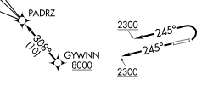

ie. The SID to the right depicts “fly HDG 245 to 2300, expect vectors to GYWNN.” From **RW24** to (VECT) is a 245° heading (displayed above the vector) with a **(2299)** altitude constraint. (The graphical SID actually depicts 2300 *or* above.)

### DISCONTINUITY

▯▯▯▯▯ = Discontinuity. A discontinuity is a break in the flight plan causing separation such as from an approach or arrival. Normally, a discontinuity can be replaced or deleted however, a discontinuity *cannot* be deleted or replaced:

* After a vector (VECT) - you must drop the waypoint on the (VECT) or delete it.
* At the end of an airway when the next waypoint is not on that airway.
* Before a leg that does not have a defined starting point such as a DME-arc.

### DELETING A WAYPOINT

To delete a waypoint (unless specified as a discontinuity above), press the CLR DEL function key. DELETE will appear in the scratchpad. Press the LEFT LSK which corresponds to the waypoint which you would like to delete. The waypoint will now be removed. The same methodology can be used to clear the DATA LINES.

### 

### 

### 

### MISSED APPROACH

If an instrument approach is selected, MISSED APPRwill appear in the data lines after the runway. All waypoints that are part of the missed approach procedure will be displayed, ending with the published hold. This segment will appear in cyan on the navigation display. Once the missed approach has been activated, it will turn white.

| **NOTE**: Missed approach procedures/waypoints do not appear unless the missed approach is activated OR, they are selected using the display/hide function which can be found under DSPL MENU by selecting MISSEDAPPRor, from the MFD LWR MENU**.** |
| --- |

The missed approach segment can be enabled by any of the three following methods:

* Pressing the TOGA button when the active waypoint is the runway (RWXX).
* Switching the LEGS sequence from INHIBIT to AUTO.
* Initiating a Direct-To any valid waypoint part of the missed approach segment.

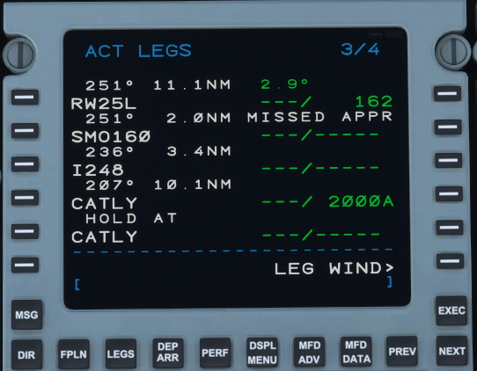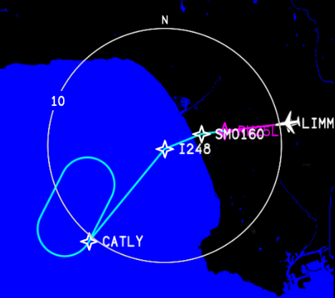

## 

## 

## 

## 

## PILOT WAYPOINTS

The Working Title CJ4 features the ability to add custom pilot waypoints. The waypoints can be added directly on the LEGS page or can be added via the PILOT WPT interface in the DATABASE page.

To add a custom waypoint directly from the LEGS page:

* Select the LEGS page.
* Enter the waypoint into the scratchpad.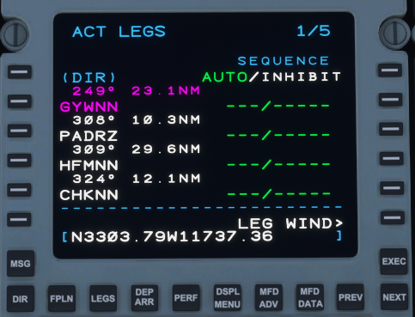
* Press the left LSK where you would like the waypoint to appear.

| **RULE:** Custom waypoints must be entered here on the LEGS page. They will not be accepted on the FPLN page. |
| --- |

The following formats are acceptable to be entered into the scratchpad as custom waypoints. NAME at the end of a custom waypoint is always optional.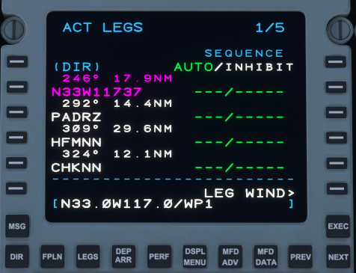

### LATITUDE AND LONGITUDE

Format: N/SDDMM.MMW/EDDDMM.MM/NAME

Example: N4412.55W00405.25

Example: N44W00405

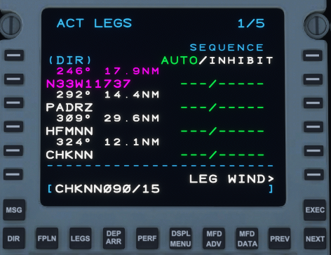

*2-Digit latitude must always come before 2-digit longitude!

### FIXBEARING/DIST/NAME

FIX=Name of the FIX (IE. CHKNN, OCN, RX15)

BEARING=Bearing FROM the FIX (090)

DISTANCE=Distance FROM the FIX in NM (15)

NAME=Custom name of waypoint if desired.

Example: OCN090/15/WP1

### ALONG TRACK OFFSET

This is useful if you need to hold a certain distance from a fix along an airway or arrival procedure, or comply with an altitude restriction.

Format: FIX/DISTANCE/NAME

ie: PADRZ/-10 Would enter a waypoint along your route 10nm BEFORE PADRZ.

ie: PADRZ/10 Would enter a waypoint along your route 10nm AFTER PADRZ.

### WAYPOINT LIST

Custom pilot waypoints added from the **LEGS** page are automatically stored in the **PILOT WPT LIST** and can be accessed by selecting **IDX** -> **PAGE 2** -> **DATABASE** -> **PILOT WPT LIST**.

To add and manage pilot waypoints, navigate to the **DATABASE** page on the FMC with **IDX** -> **PAGE 2** -> **DATABASE**:

* Select **PILOT WPT LIST** to see a list of already saved pilot waypoints.
* Select **DEFINE WPT** to create and store a new pilot waypoint.

On the **PILOT WPT LIST** page: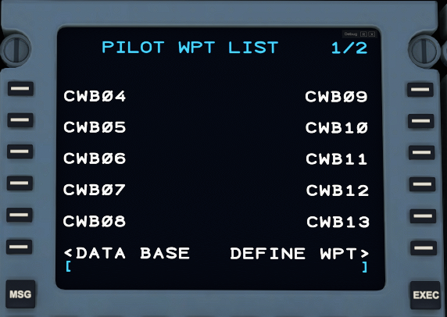

* To view or edit an existing pilot waypoint, click on the LSK adjacent to the existing pilot waypoint; this will open the **DEFINE PILOT WPT** where you can delete the pilot waypoint.
* Select **DEFINE WPT** to create and store a new pilot waypoint.

On the **DEFINE PILOT WPT** page:

* Create a new pilot waypoint by entering a unique IDENT and then either specifying coordinates or a Fix Bearing/Distance reference. The input rules for this page are the same as they are on the prior page for **LEGS** page entry (see above). Once you are satisfied with your IDENT and location, select **STORE WPT** to save the pilot waypoint.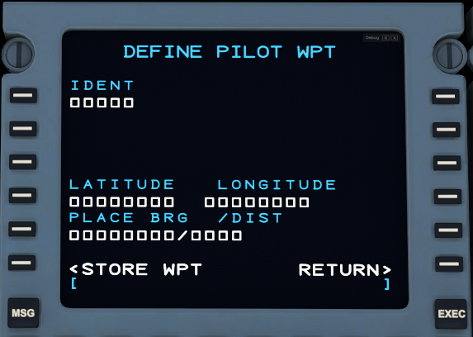

| **RULE:** A maximum of 20 pilot waypoints can be saved; upon storing the 21st pilot waypoint, the first pilot waypoint will be deleted. These are overwritten with FIFO logic (first in first out). |
| --- |

| **RULE:** Pilot waypoints may not have the same IDENT as any other pilot waypoint or waypoint in the official nav database. |
| --- |

## DIRECT TO

Direct To allows for the aircraft to proceed to any valid waypoint in the flight plan without going through the predefined sequence. There are two ways to initiate a direct-to a waypoint.

| **RULE:** It is not possible to go DIRECT TO a vector (VECT). |
| --- |

| FROM LEGS PAGE The first and most common method is to select the fix you wish to go direct-to from the ACT LEGS page. You can select any waypoint on any of the LEGS pages, including the one you are already going direct-to. In this case, we’ll go direct-to GYWNN on PAGE 1/4. Select GYWNN on LSK 5L. It will then copy to the scratchpad. Then, select LSK 2L**,** the current (2299) fix. GYWNN will now be placed into LSK 2L, removing all waypoints before it. EXEC the command and the aircraft will now go direct to GYWNN. |
| --- |
| FROM DIR PAGE The second method of going direct is from DIRon the FMS function keys. Press the DIR button to bring up the ACT DIRECT-TO page. Select the fix you wish to go direct-to, cycling through pages as necessary. In this case, HUNDA on PAGE 1. Click LSK 3L to select. It will then bring you to the MOD LEGS page with the waypoint already placed in L2. Hit EXEC to confirm, MOD LEGS will become ACT LEGS, and the aircraft will now go direct to HUNDA. |

### 

### VERTICAL DIRECT-TO

Vertical Direct-To allows the pilot to command the VNAV to go direct to an altitude constraint that already exists at a waypoint. To initiate a vertical direct-to, enable VNAV and autopilot from the FMA, and find the waypoint which corresponds to the altitude in **green**, on the right hand side of the FMS, in which you wish to climb or descend to. It will then place that altitude in **magenta**, above the VSI, as the Flight Plan Target Altitude and VNAV will now calculate and follow a path to the newly selected altitude. The altitude preselector must be at or below your new target altitude.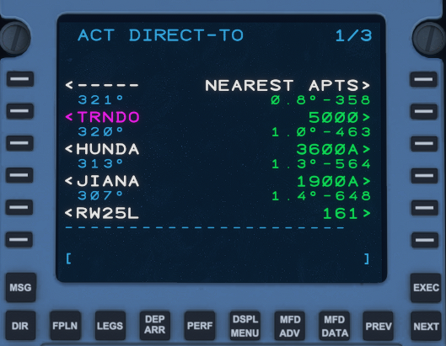

This page also displays the slope between waypoints and the required vertical speed based on present ground speed.

| **NOTE**: Selecting an DIRECT TO altitude will NOT go DIRECT TO the waypoint fix it corresponds with. It is changing altitude only. |
| --- |

| **NOTE**: Going DIRECT TO an altitude will CLEAR all other altitude constraints before it. |
| --- |

### NEAREST AIRPORTS

You can also go direct-to a nearby airport. From the DIR page, select NEAREST APTS. You will then be presented with a screen that lists your ORIGIN, your DESTINATION and the 3 nearest airports within a 200NM radius based on editable runway length. Default is 5000 but it will accept any value between 0 and 19999’. Select the airport you wish to go direct-to using the LSKs.

## 

## 

## HOLDS

Another important feature of the FMS-3000 is the HOLD function. These are flown as “race-track” patterns to delay an arrival or keep an aircraft over a particular spot until ATC can provide proper sequencing.

### CREATING A HOLD

To initiate a hold, press IDX>HOLD. You will then be taken to the ACT LEGS page. Find the page which contains the fix which you would like to hold at, or enter it manually into the scratchpad and press LSK 6L.

For this scenario, ATC requests that we “hold as published, present altitude, on the arrival at ROBIE, 1 minute legs” and an EFC time of 21:45z. The inbound course as listed on the ROBIE5 arrival chart is 308° with right-hand turns. PressLSK 4L **(1)** to bring ROBIE into the scratchpad. Once ROBIE is in the scratchpad, press LSK 6L **(2)** to initiate the HOLD set up process. 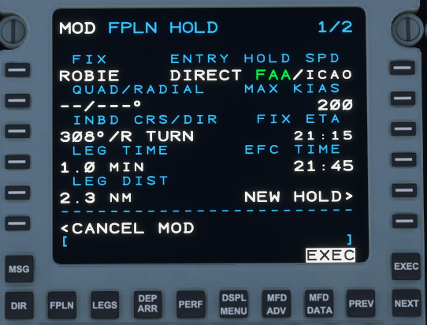

Once a hold has been entered in LSK 6L, you will be taken to a screen that says MOD FPLN HOLD. This is where the hold parameters can be entered and/or modified.

* **FIX** - Current fix you are creating the hold on.
* **QUAD/RADIAL** - **NOT IMPLEMENTED**
* **INBD CRS/DIR** - The inbound course to the FIX followed by the turn direction of the holding pattern, L or R.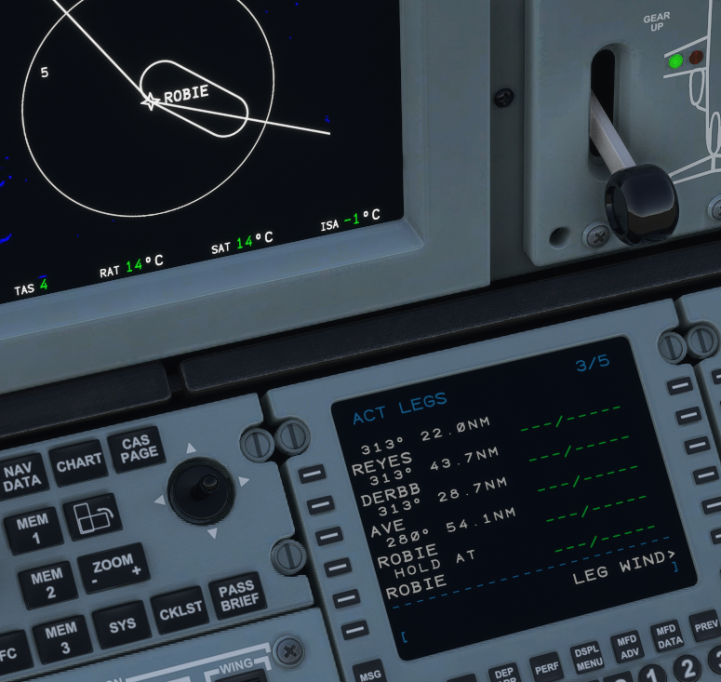

| **RULE**: Only a 3-digit radial (001°- 360°) plus a direction will be accepted by the FMS. (ie. 308/R, 090/L, 008/R) |
| --- |

* **LEG TIME** - Time in minutes for inbound/outbound legs.
* **LEG DIST** - Distance in NM for inbound/outbound legs.

| **RULE:** You can either enter the LEG TIME or LEG DISTANCE, it is NOT possible to define both simultaneously. Defining one will define the other based on current groundspeed.  ie: 1.0 MIN LEG TIME = 2.3 NM LEG DIST  ie: 4.0 NM LEG DIST = 2.0 MIN LEG TIME |
| --- |

* **ENTRY** - Automatically selected based on the incoming course to the hold FIX from the previous waypoint. Possible options are DIRECT (Direct), TEARDP (Teardrop), or PARALL (Parallel) - these cannot be modified by the user.
* **HOLD SPEED** - Selectable to FAA or ICAO. Will determine MAX recommended KIAS holding speed based on present altitude. Advisory only. (*See FAA or ICAO hold limits for more information.)*
* **FIX ETA** - Estimated time of arrival to the hold fix. If you are already established in the hold, it is the time to complete a lap to cross the fix again.
* **EFC TIME** - Expect Further Clearance Time. Advisory only.
* **NEW HOLD** - Reinitiates the HOLD creation process for additional holds if required.

When the hold is configured as required, press EXEC to insert it into the flight plan. The hold FIX will be duplicated in the LEGS page and HOLD AT will appear above it.

### HOLD LIST

When more than one hold has been configured, upon accessing the HOLD page from the INDEX, you will be presented with the ACT HOLD LIST. This list contains all active holds in a flight plan. Use the Left LSK to select any active holds you wish to modify.

| **RULE**: The maximum number of holds that can be entered at any one time is six (6). |
| --- |

### 

### DELETING A HOLD

To delete a hold, press the CLR DEL key followed by the corresponding LSK on the left side of the FMS, followed by the EXEC key to delete.

### 

### 

### EXITING THE HOLD

To exit a hold, you may press LEGS>EXIT HOLD. The FMS will then note EXIT ARMED. You may also exit the hold from FPLN HOLD. If you wish to stay in the hold, you can cancel the hold exit from both LEGS and FPLN HOLD.

| **NOTE** - Upon arming a hold exit, the plane may immediately exit if it has already passed abeam the hold fix. From elsewhere in the hold pattern, the FMS will direct the plane to turn to the inbound leg. This turn cannot be canceled. However, if **CANCEL HOLD** is pressed, the plane will continue to fly the holding pattern after passing the hold fix. |
| --- |

### 

### 

### 

## 

## TUN (TUNE)

The TUN (tune) page is where all aircraft radio frequencies and transponder codes are entered.

TUNE 1/2

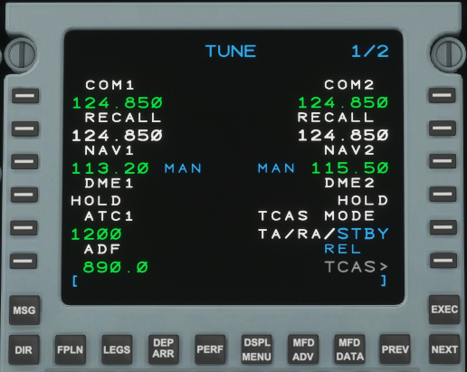

* **COM1** - Contains the **active** COM1 frequency.
* **COM2** - Contains the **active** COM2 frequency.

Entering a new frequency in the COM1/2 line will “bump” the current frequency down to RECALL.

| **NOTE**: All frequencies can be entered using shorthand by omitting the “1” or decimal point such as: **24.85 or 2485 (124.850)**, **8.7 (108.700)**, or **191 (119.100)**. |
| --- |

* **RECALL** - Contains the standby frequency for COM1 or COM2. Entering a frequency in the RECALLallows for easy access of past or future frequencies when instructed to change by ATC. To swap between the active and RECALL frequency below, press LSK 2L/2R.
* **NAV1** - Displays the current frequency of the NAV1 radio.
* **NAV2** - Displays the current frequency of the NAV2 radio.
* **DME1** - **NOT IMPLEMENTED**
* **DME2** - **NOT IMPLEMENTED**
* **ATC1** - Transponder (squawk) code as assigned by Air Traffic Control.

| **RULE**: Transponder code must be a 4-digit number only using numerals 0-7 |
| --- |

* **TCAS MODE** - Toggles transponder state between TA/RA and STBY. TA/RA enables the transponder to transmit Mode C data - this is more complex in the real aircraft, but currently in the sim or for online clients such as vpilot, TA/RA basically just turns the transponder ON (Mode C).
* **TCAS>** - Displays the TCAS CONTROL Menu.

**REL/ABS** - Displays current traffic altitude as either RELative or ABSolute.

* **ADF** - Automatic Direction Finder or NDB (Non-Directional Beacon) radio frequency.

TUNE 2/2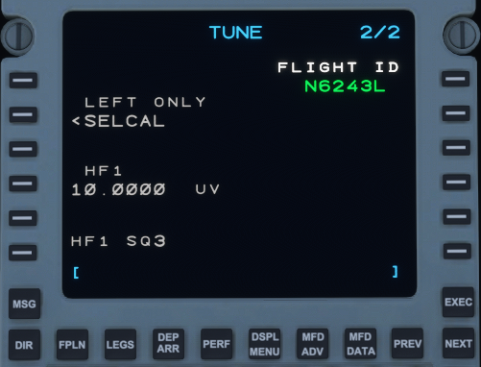

* **FLIGHT ID** - Displays Flight ID (tail number) for ADS-B out. Has no function in MSFS.

### 

### 

### 

### 

### COM CONTROL

Clicking on either COM1 or COM2 without a frequency in the scratchpad, will bring up the COM CONTROL page. This page contains additional configuration options for the COM1/2 radios as well as stored presets. You can return to TUNE 1/2 by pressing on the COM1(2) frequency LSK (1L) while the scratchpad is empty or by pressing the TUN key.

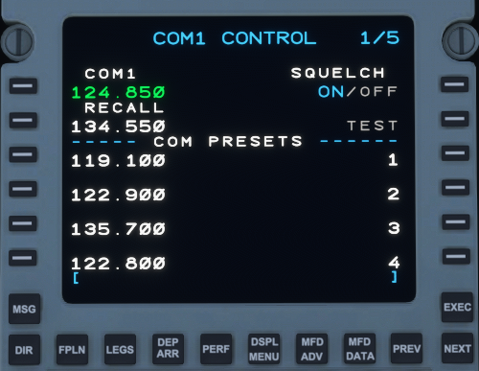

* **COM1(2)** - Displays the current frequency of the COM1 or COM2 radio.
* **RECALL** - Contains the standby frequency for COM1 or COM2.
* **SQUELCH** - **NOT IMPLEMENTED**
* **COM PRESETS** - Contains up to twenty (20) COM presets per radio. Additional frequencies can be accessed using the **NEXT** and **PREV** keys. To add a preset, enter it into the scratchpad and select the corresponding left LSK where you would like it to store. (Presets can also be entered using the shorthand described above.) To select a preset, click the left LSK next to the corresponding frequency to bring it into the scratchpad, and then select LSK 1L to enter it into the **active** COM slot.

| **NOTE:** Presets cannot be deleted, they must be overwritten with a new frequency. |
| --- |

### 

### NAV CONTROL

Clicking on either NAV1 or NAV2 without a frequency in the scratchpad, will bring up the NAV CONTROL page. This page contains additional configuration options for the NAV1/2 radios as well as stored presets. You can return to TUNE 1/2 by pressing on the NAV1(2) frequency LSK (1L) while the scratchpad is empty or by pressing the TUN key.

| **NOTE**: NAV CONTROL is not accessible while avionics are in DISPATCH mode. |
| --- |

* **NAV1(2)** - Displays the current frequency of the NAV1 or NAV2 radio.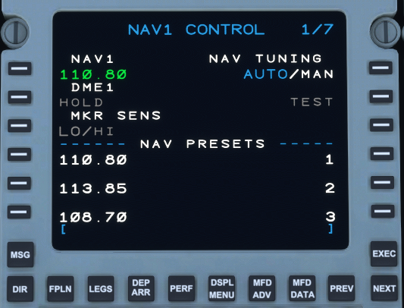
* **DME1** - **NOT IMPLEMENTED**
* **HOLD** - **NOT IMPLEMENTED**
* **MKR SENS** - **NOT IMPLEMENTED**
* **NAV TUNING** - AUTO/MAN. If AUTO is selected using LSK 1R, the selected NAV radio will auto-tune to the nearest VOR every 6 minutes. Found VORs will be displayed if the BRG sources are shown on the HSI. In the real aircraft, this is used to refine the aircraft’s position, but position updates are not currently modeled in the sim. In MAN (manual) mode, the radio will stay tuned to whichever frequency was selected by the pilot. The NAV to NAV transfer mode, such as the FMS auto-tuning an ILS frequency when an approach is loaded, will trigger in the MAN or AUTO state.

| **NOTE**: The MSFS VOR search function may not always be 100% reliable. This is a limitation of the sim and something we are currently looking into. |
| --- |

* **NAV PRESETS** - Contains up to twenty (20) NAV presets per radio. Additional frequencies can be accessed using the NEXT and PREV keys. To add a preset, enter it into the scratchpad and select the corresponding left LSK where you would like it to store. (Presets can also be entered using the shorthand described above.) To select a preset, click the left LSK next to the corresponding frequency to bring it into the scratchpad, and then select LSK 1L to enter it into the **active** NAV slot.

| **NOTE:** Presets cannot be deleted, they must be overwritten with a new frequency. |
| --- |

### ATC CONTROL

The ATC CONTROL page contains several options relating to the transponder. It can be accessed by pressing on the transponder code under ATC1 (LSK 5L) while the scratchpad is blank. You can exit the ATC CONTROL menu similarly by pressing ATC1 (LSK 1L), with a blank scratchpad, while in the ATC CONTROL sub-menu or by pressing the TUN function key.

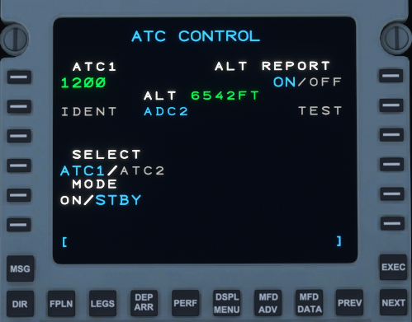

* **ATC1** - Transponder (squawk) code as assigned by Air Traffic Control. (This is the same code found on TUNE 1/2.)
* **IDENT** - **NOT IMPLEMENTED**
* **SELECT** - Toggles the transponder output between transponder 1 and 2. **NOT IMPLEMENTED**
* **MODE** - Toggles transponder state between ON and STBY. ON enables the transponder to transmit Mode C data - this functions differently in the real aircraft, but currently in the sim or for online clients such as vpilot, ON basically just turns the transponder ON (Mode C). (Functionality is also tied to TCAS MODE on TUNE 1/2.)
* **ALT** - Current Pressure Altitude of the aircraft.
* **ALT REPORT** - Toggles the transponder to output pressure altitude data. **ALWAYS ON**, **NOT IMPLEMENTED**
* **TEST** - **NOT IMPLEMENTED**

### ADF CONTROL

The ADF CONTROL page contains several options relating to the ADF (Automatic Direction Finder) radio. It can be accessed by pressing on the frequency under ADF1 (LSK 6L) while the scratchpad is blank. You can exit the ADF CONTROL menu by pressing ADF1 (LSK 1L), with a blank scratchpad or by pressing the TUN function key.

* **ADF PRESETS** - Contains up to twenty (20) ADF presets. Additional frequencies can be accessed using the NEXT and PREV keys. To add a preset, enter the frequency into the scratchpad and select the corresponding left LSK where you would like it to store. To select a preset, click the left LSK next to the corresponding frequency to bring it into the scratchpad, and then select LSK 1L to enter it into the **active** ADF slot. Presets cannot be deleted, they must be overwritten with a new frequency.

### TCAS CONTROL

The TCAS CONTROL page contains several options relating to the Traffic Collision Avoidance System. It can be accessed by pressing on the TCAS button (LSK 6R). The TUN button must be pressed to return to the primary radio page.

| **NOTE**: Resolution Advisories (RAs) are currently not modeled. |
| --- |

| **NOTE**: Maximum TCAS display range is 40nm. |
| --- |

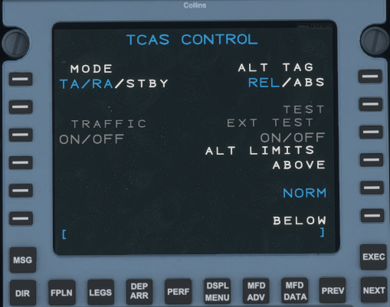

* **Mode** - Toggles transponder state between ON and STBY. ON enables the transponder to transmit Mode C data - this functions differently in the real aircraft, but currently in the sim or for online clients such as vpilot, ON basically just turns the transponder ON (Mode C). (Functionality is also tied to TCAS MODE on TUNE 1/2.)
* **ALT TAG** - Altitude Tag. Toggles the altitude tag display readout to display the altitude of targets between ABSOLUTE and RELATIVE. Absolute displays target’s *pressure altitude* to three (3) significant figures. (002 = 200’, 035 = 3500’, 225 = 22500’). RELATIVE will display target’s altitude (to two (2) significant figures) *relative* to the current altitude of the aircraft with a “+” indicating the target is *above* you and “ -” indicating the target is *below* you (+32 = 3200’ above, - 02 = 200’ below). The current ALT TAG is also displayed in cyan text on TUNE 1/2 above the TCAS button.
* **TRAFFIC** - **NOT IMPLEMENTED**
* **TEST - NOT IMPLEMENTED**
* **EXT TEST - NOT IMPLEMENTED**
* **ALT LIMITS** - ABOVE, NORM and BELOW is used to filter TCAS data targets. NORM displays all targets within 2700’ both above and below. ABOVE shows all targets from your current altitude to 9900’ *above*, relative to the aircraft. BELOW shows all targets from your current altitude to 9900’ *below* relative to the aircraft (ALT TAGS can still display ABS values when ABOVE and BELOW are selected). It is also possible to toggle both ABOVE and BELOW simultaneously.

### DISPATCH

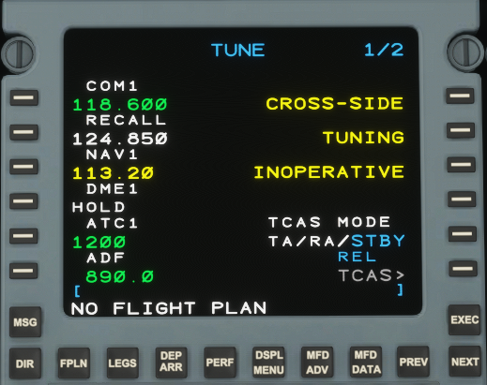

When the AVIONICS switch at the electrical panel is switched to DISPATCH, the TUNE page of the FMS will revert to DISPATCH mode. This mode only powers essential systems and a single FMS for preflight planning. Only the first radios (COM1, NAV1, ATC1 and ADF) are available in this mode.

When the AVIONICS switch is moved into the ON position, the rest of the TUNE page will be activated.

| **NOTE:** All control pages are accessible when in dispatch mode *except* for NAV1. |
| --- |

## 

## 

## 

## 

## 

## 

## 

## 

## 

## 

## 

## 

## MFD ADV

The MFD ADV menu allows for the user to step through flight plan waypoints from the LEGS page when the MFD map is in PLAN mode (*LWR MENU*). The waypoints will then be centered in the PLAN map.

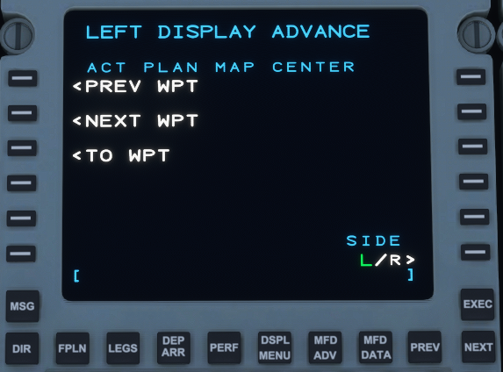

* **PREV WPT** - Cycles PLAN view to center on the previous waypoint.
* **NEXT WPT** - Cycles PLAN view to center on the next waypoint.
* **TO WPT** - Centers the PLAN view on the **magenta** waypoint the aircraft is currently flying to.

| **NOTE:** Before stepping through any waypoint, the PLAN view will stay centered and follow the aircraft. Once you step through a waypoint, it cannot be re-centered on the aircraft. The real unit never centers and tracks on the aircraft. This page of the FMS is still a work-in-progress and may be updated at a later date. |
| --- |

## 

## 

## 

## 

## 

## 

## DSPL MENU

The display menu controls items to be displayed on the MFD/PFD in PPOS or PLAN view. Activated items will be highlighted in green. Items in gray are not yet available.

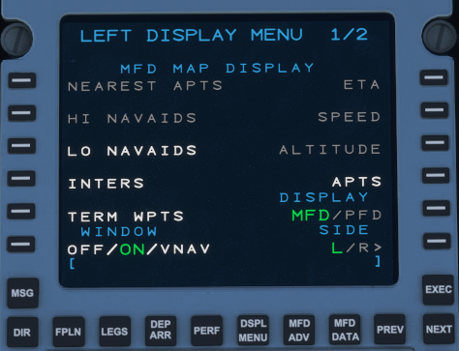

* **LO NAVAIDS** - Display or hide both HIGH and LOW VORs.
* **INTERS** - Display or hide intersections.
* **TERM WPTS** - Display or hide Terminal Waypoints.
* **WINDOW** - Changes the FMS text to show VNAV information in place of ETA, fuel, and landing weight. ON and VNAV are currently the only two selectable options. (*See* *FMS TEXT* *under MFD*)
* **APTS** - Display or hide Airports.
* **MISS APPR** - Display or hide the missed approach procedure on the map in cyan.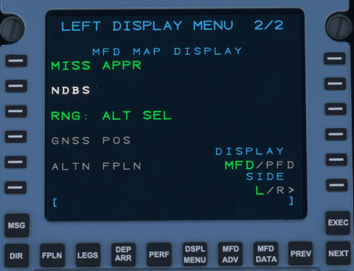
* **NDBS** - Display or hide NDBs.
* **RNG: ALT SEL** - Show or hide the range select altitude “banana.”

**THIS PAGE HAS BEEN INTENTIONALLY LEFT BLANK**

# 6 - AUTOPILOT OPERATION LIMITATIONS

| Minimum engage height after takeoff | 300ft AGL |
| --- | --- |
| Minimum disengage height during approach | 200ft AGL |
| Yaw damper | Must be engaged after liftoff, disengaged before touchdown |

## FLIGHT GUIDANCE PANEL

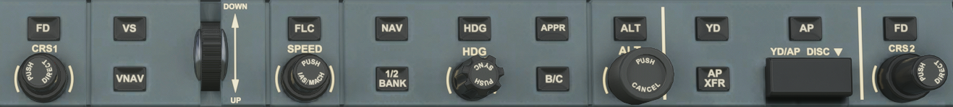

**Fig 6.1 - Flight Guidance Panel**

### FD

The **FD** button on the FGP enables or disables the flight director on the PFD. The flight director will now give appropriate lateral guidance even when the autopilot is disengaged, as of 0.9.1. The co-pilot independent flight director is not currently modeled.

### VS

The **VS** button on the FGP enables or disables the Vertical Speed Hold mode of the Flight Guidance System. In this mode, the plane will adjust pitch to meet the desired vertical speed. The vertical speed can be selected using the vertical speed/pitch wheel, indicated by the **DOWN** and **UP** indications to the right of the wheel.

### VNAV

The **VNAV** button on the FGP enables or disables VNAV. VNAV in the climb phase is an over-the-top mode that commands altitude captures at programmed restrictions in the flight plan while still climbing using the underlying selected vertical mode (**VS** or **FLC**). VNAV in the descent phase may be used as an over-the-top mode similar to the climb phase, but also provides a calculated descent path using the defined Flight Path Angle to meet the arrival and approach restrictions if no other vertical mode is selected. The default descent flight path angle is 3°. More details are available later in this chapter in the dedicated VNAV Operations section.

### FLC

The **FLC** button on the FGP enables or disables Flight Level Change mode of the flight guidance system. In this mode, the plane will adjust pitch to keep the selected FLC airspeed. As such, the aircraft will increase pitch to slow, and decrease pitch to gain speed. The selected speed can be changed using the knob labeled **SPEED**. Pressing the **SPEED** knob will toggle the speed hold between IAS and Mach hold modes. The selected speed bug **will not** be visible on the PFD unless FLC is the active vertical mode.

| **NOTE -** The Cessna Citation CJ4 is not equipped with an autothrottle. Selecting FLC will not automatically adjust the throttle to meet the desired airspeed. Airspeed in FLC is controlled **only** by plane pitch angle. It is the pilot’s responsibility to select the correct throttle setting for the desired climb or descent rate. |
| --- |

### NAV

The **NAV** button on the FGP enables or disables FMS or radio LNAV. If the currently selected navigation source is the FMS, the FGS will command the aircraft to follow FMS guidance via the flight plan. However, if the currently selected navigation source is either NAV1 or NAV2, then the FGS will follow the selected nav radio. Changing the selected radial course to the nav source can be accomplished using the **CRS1** (for NAV1) and **CRS2** (for NAV2) knobs on the FGP. Pressing either knob will select a course that takes the aircraft directly to the tuned nav source.

If the current nav source is FMS, pressing **NAV** arms the **LNV** FGS mode. The plane will continue to fly in the current mode until within capture distance from the desired FMS course. When the course is captured, the current lateral mode will be disengaged and **LNV** will become the active lateral navigation mode.

### ½ BANK

The **½ BANK** button will engage or disengage ½ Bank mode, which limits the maximum bank of the aircraft. Normal maximum bank is 30°, and ½ bank is 15°.

### HDG

The **HDG** button on the FGP enables or disables the Heading Hold mode of the FGS, which commands the plane to follow the currently selected FGP heading. The selected FGP heading can be changed using the knob on the FGP labeled **HDG**. Pressing the HDG select knob will synchronize the selected heading to the current airplane heading.

### APPR

The **APPR** button on the FGP enables or disables the Approach mode of the FGS. The Approach mode is a unique mode in that it controls both the **APPR LNV** or **APPR LOC** lateral modes and the **GS** or **GP** vertical modes.

Enabling approach mode during an ILS approach will arm **APPR LOC** and arm **GS**, while continuing to provide guidance in the current active mode. When the localizer is captured, **APPR LOC** will become the active lateral mode, and when the glideslope is captured, **GS** will become the active vertical mode. while enabling approach mode during a RNAV approach will activate **APPR** and arm **GP**.

Similarly, enabling approach mode during an RNAV approach will arm **APPR LNV** and arm **GP**, while continuing to provide guidance in the current active mode. When the lateral FMS course is captured, **APPR LNV** will become the active lateral mode, and when the vertical glidepath is captured, **GP** will become the active vertical mode.

### B/C

The **B/C** button on the FGP enables or disables ILS backcourse approach mode. This mode will direct the FGS to fly the backcourse of the tuned ILS navigation source. **B/C** mode does not apply to RNAV approaches. - NOT IMPLEMENTED

### ALT

The **ALT** button on the FGP enables or disables altitude hold mode on the FGS. This mode directs the aircraft to hold the selected FGP altitude. The selected altitude can be changed with the **ALT** knob. Pressing the **ALT** knob will synchronize the selected altitude with the current altitude.

### YD

The **YD** button on the FGP enables or disables the aircraft yaw damper. The yaw damper is always engaged if the autopilot is engaged. YD will appear in place of AP when the yaw damper is manually engaged without the autopilot.

### AP

The **AP** button on the FGP enables or disables the autopilot (FGS). Enabling the autopilot will immediately command the aircraft to follow the selected FGS modes.

### YD/AP DISC

The **YD/AP DISC** breaker bar forcibly disconnects the FGS from commanding the aircraft control surfaces. This bar is only used in emergency scenarios when the autopilot cannot be disengaged via normal means. Pressing the bar back in reconnects the FGS.

## FLIGHT GUIDANCE SYSTEM DISPLAY (SCOREBOARD)

The Flight Guidance System display is located at the top of the pilot and co-pilot Primary Flight Displays (PFD). This display annunciates the status of the FGS and what FGS modes are armed and/or currently active, reflecting the mode selections of the pilot as pressed on the Flight Guidance Panel (FGP).

| Active Lateral Mode | AP/YD Status | Active Vertical Mode |  | Active Vertical Mode |
| --- | --- | --- | --- | --- |
| LNV1 | AP | VS 2000 |  | VS 2000 |
| APPR | ← |  | PATH | GS |
| Armed Lateral Mode | Active FGS Side | Armed Vertical Mode | VNAV Armed Mode | Armed Approach Mode |

**Fig 6.2 - FGS Display Layout**

| Active Lateral Mode | The currently active lateral guidance mode being followed by the FGS. Valid modes are:   * **ROLL** - Commands the plane to roll to level * **HDG** - The plane will follow the selected heading from the FGP * **LNV1** - The plane will follow the flight path directed by the FMS flight plan * **NAV** - The plane will follow the selected nav radio source * **APPR LNV1/LOC** - The plane will follow the selected approach * **TO** - The plane will follow the runway heading |
| --- | --- |
| Armed Lateral Mode | The currently armed but not yet active lateral guidance mode. Valid modes are the same as the above modes. |
| AP/YD Status | The current status of the autopilot and yaw damper. The yaw damper is always engaged if the autopilot is engaged.   * **AP** - The autopilot is engaged * **YD** - The yaw damper is engaged*   *YD will not be annunciated when AP is engaged |
| Active FGS Side | The currently active FGS side (pilot side or copilot side). If the active side points towards the pilot position, the annunciation will be green, else it will point away and be white. *Currently the active side is always the pilot side.* |
| Active Vertical Mode | The currently active vertical guidance mode being followed by the FGS. Some vertical modes will be preceded by a **V** if VNAV is currently enabled. Valid modes are:   * **PITCH** - The plane will follow the selected FGP pitch * **FLC** - The plane will adjust pitch to meet the selected FGP airspeed * **VS** - The plane will follow the selected FGP vertical speed * **ALT** - The plane has captured a baro altitude. * **ALTS (CAP)** - The plane is at or will capture the FGP selected altitude when reached * **ALTV (CAP)** - The plane is at or will capture the VNAV directed altitude when reached * **PATH** - The plane will descend along the calculated VNAV path * **TO / GA -** The plane will be directed to a 10° nose-up pitch * **GS** - The plane will follow the selected and tuned ILS approach glideslope * **GP** - The plane will follow the RNAV approach descent glide path |
| Armed Vertical Mode | The currently armed but not yet active vertical guidance mode. Valid modes are the same as the above modes. |
| Armed VNAV Mode | The currently armed VNAV vertical mode. Valid modes are:   * **PATH** - The plane will descend along the calculated VNAV path * **~~PATH~~** - The plane is unable to automatically descend along the calculated VNAV path because the plane is too far above the path |
| Armed Approach Mode | The current armed vertical approach mode. Valid modes are:   * **GS** - The plane will follow the selected and tuned ILS approach glideslope * **GP** - The plane will follow the RNAV approach descent glide path |

## VNAV OPERATION

The VNAV mode of operation provides vertical navigation that respects the flight plan defined altitude restrictions during the climb, cruise, and descent phases of flight. Flight plan altitude restrictions are automatically loaded when a departure, arrival, or approach procedure are selected on the FMC **DEP/ARR** pages, and may also be entered by the pilot into the FMC **LEGS** page manually.

| **NOTE** - The CJ4 FMC does not operate the same as an airliner style FMC for VNAV operations. The FMC will display **only** loaded or entered altitude restrictions and **will not** populate anticipated altitude crossings at each fix. This is normal operation, and VNAV will still fly the calculated path.  There is no need to populate altitude restrictions for each fix. |
| --- |

VNAV will automatically determine if you are in the climb or descent phase by looking at the current flight plan segment.

### VNAV CLIMB

In VNAV climb (climbing to the selected altitude with VNAV engaged), VNAV will not calculate a climb path. The climb rate is at the pilot’s discretion, and is managed using **VS** (indicated by **VVS** while in VNAV) or **FLC** (indicated by **VFLC** while in VNAV). However, VNAV will look at the programmed climb altitude restrictions and will select an altitude to hold at to maintain those restrictions. VNAV will also arm FLC at the programmed speed entered in the **VNAV SETUP** page and automatically transition to make **FLC** active when the restriction has passed.

Because the climb rate is at the pilot’s discretion, **AT OR ABOVE** restrictions are up to the pilot to meet. VNAV will hold altitude for **AT** and **AT OR BELOW** restrictions.

### VNAV DESCENT

In VNAV descent, the default vertical guidance mode (with no other vertical modes selected) is **PATH**. VNAV Path calculates 1 or more descent segments to fly, taking into account programmed altitude restrictions, based on the Flight Path Angle defined in FMC **VNAV SETUP**. VNAV Path will split the descent into multiple segments in the case where a level-off at a restriction altitude is required during a leg of the descent.

Each VNAV descent segment is preceded by a Top Of Descent (TOD) marker in green on the PPOS and PLAN PFD/MFD map displays. The TOD marker will appear on the map no later than when the aircraft is within ~20NM from the calculated top of descent for the current descent segment. It is normal to encounter multiple level-offs with TODs during a planned descent.

### VNAV PATH

When the aircraft is within 1000ft of the calculated VNAV descent path, VNAV will automatically arm **PATH** with the FGS. This informs the pilot that when the descent path is captured, that **PATH** will become the active vertical guidance mode, and that the plane will follow the calculated descent path. Vertical guidance will continue to track the calculated descent path, leveling off for programmed altitude restrictions as necessary. If the pilot selected altitude is to be captured, the armed vertical mode will be **ALTS**. If the VNAV target altitude is to be captured, then the armed vertical mode will be **ALTV**.

If the aircraft is above the capture range of the path during a planned descent segment, **~~PATH~~** will appear in the armed VNAV mode slot. This indicates that VNAV cannot capture the path from above from the current position, and the pilot will need to descend to the path using **VS** or **FLC** modes.

VNAV does not adjust or actuate the aircraft engine throttle. It is up to the pilot to manage the aircraft horizontal speed manually with throttle control.

## VNAV DISPLAY

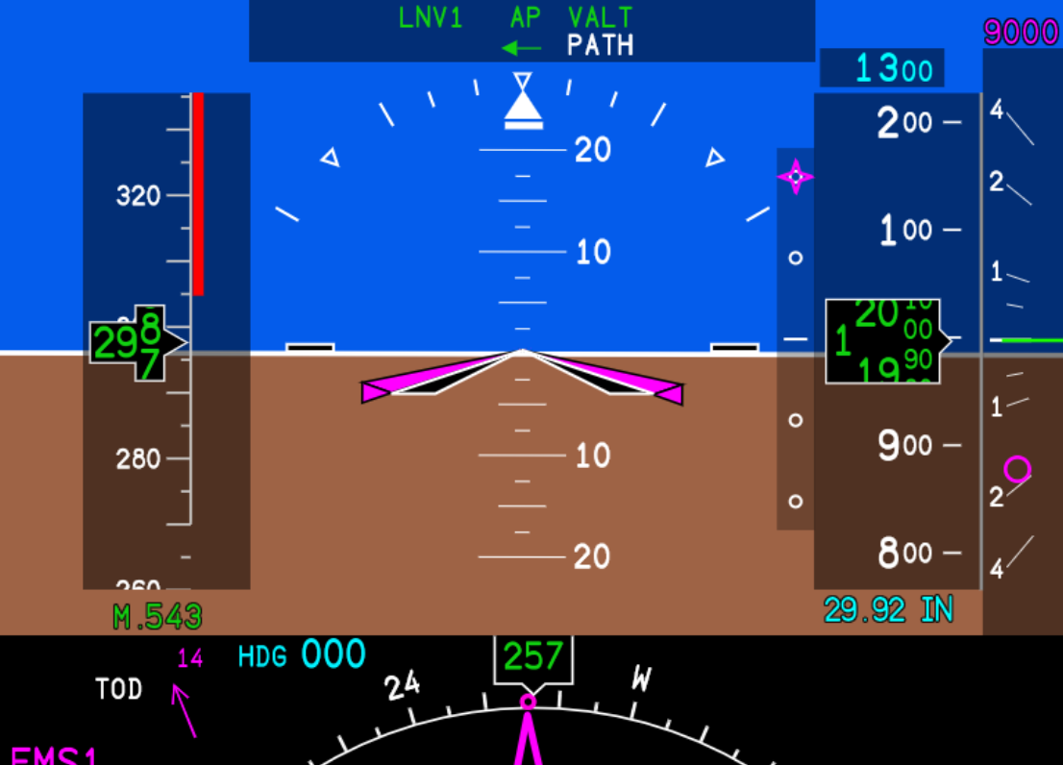

| Vertical Deviation Indicator | The vertical deviation indicator, appearing to the left of the altitude tape, indicates the amount of deviation from the calculated VNAV descent path. The magenta snowflake indicates the aircraft’s current vertical deviation from the path. |
| --- | --- |
| VNAV Target Altitude | The VNAV target altitude indication, a magenta altitude that appears above the vertical speed bar, shows the next programmed restriction in the plan. This restriction will appear if the selected altitude is under the restriction, indicating to the pilot that the restriction is taking precedence over the lower selected altitude. |
| Vertical Speed Advisory Pointer | The vertical speed advisory pointer appears as a magenta donut in the vertical speed bar, and shows the minimum vertical speed required to meet the next programmed restriction, if the descent was to be immediately initiated. |
| PFD TOD Alert | A TOD alert will appear on the upper left of the bottom half of the PFD display when the plane is within 1000ft vertical deviation of the next TOD. The TOD alert will flash approximately 5-10 seconds before the descent is initiated to alert the pilot to an impending vertical speed change that will require throttle management. |

**THIS PAGE HAS BEEN INTENTIONALLY LEFT BLANK**

# 

# 7 - DISPLAYS

## PFD - PRIMARY FLIGHT DISPLAY

The Primary Flight Display (PFD) shows basic flight information such as pitch, roll, yaw, airspeed, and altitude. In addition, it also displays many other sources of information such as those coming from the FMS and other NAV sources. PFD functions are controlled via the DCP (Display Control Panel) located above it.

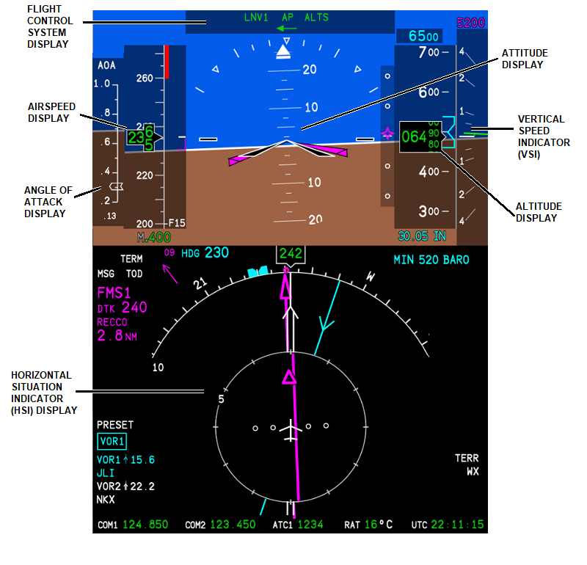

**Fig 7.1a - Primary Flight Display**

#### PFD ATTITUDE INDICATOR

**Fig 7.1b - Primary Flight Display Top**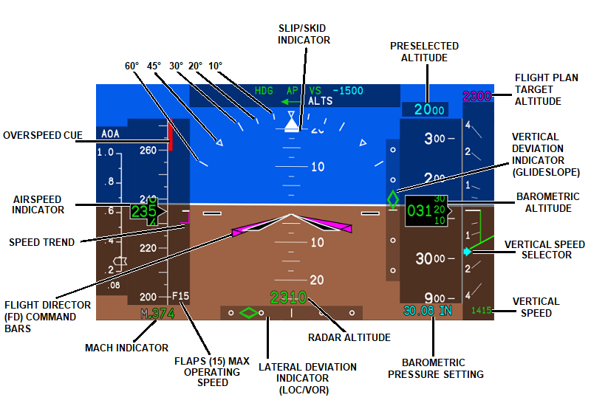

#### PFD HSI

**Fig 7.1c - Primary Flight Display HSI**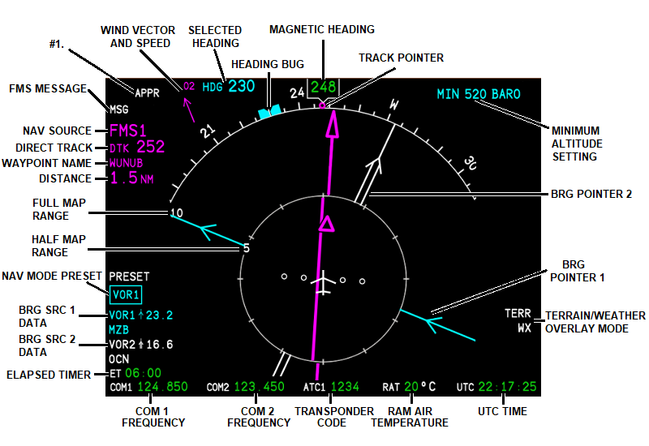

**#1**. - LNAV (FMS) accuracy. Displayed messages correspond to the accuracy of the system under various phases of flight. In the image above, APPR is depicted as corresponding to an accuracy of 0.3nm or less. Below are the normal accuracies for each phase when certain criteria are met:

Enroute - 2nm - (No display)

TERM - 1nm - Displays 31nm or less from destination.

APPR - 0.3nm - Displayed before the FAF (Final Approach Fix) when using FMS/GPS sources.

LPV APPR - 0.02nm - Displayed before the FAF when using an LPV approach.

These are not to be confused with the deviation dots of the course pointer (the magenta needle). The deviation for each NAV source is as follows when selected as the primary source. The following values are for EACH DOT.

VOR - 5 degrees of deviation.

LOC - 1 degree of deviation.

FMS - 5.0 nm Enroute.

- 1.0 nm for GPS/FMS APPR.

**THIS PAGE HAS BEEN INTENTIONALLY LEFT BLANK**

### DCP - DISPLAY CONTROL PANEL

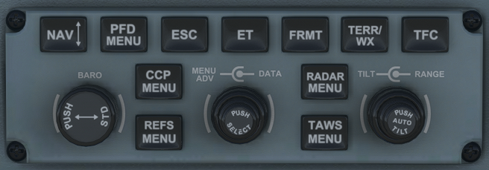

**Fig 7.2 - Display Control Panel**

The DCP (Display Control Panel) controls all the configurable options for the Primary Flight Display (PFD).

**MENU ADV**

Menu Advance Knob - Allows the user to scroll through PFD MENU options and data. Selected content will be outlined by a CYAN box.

|  | **DATA VALUE** |
| --- | --- |
|  | **DATA 123** |
| **◯** | **OPTION** |
| **⬤** | **OPTION** |
| ▶ | **SUBMENU** |

#### DATA

Data Knob - Allows data fields selected from the MENU ADV to be changed.

**PUSH SELECT**

Push Select Button - Used to enable/disable items highlighted with a 𐩒 or ⃞ toggle, or enter sub-menus. Lists noted with a 𐩒 denote that only one option can be selected. Lists with a ⃞ denote that any number of items can be selected from the category. Once you scroll to the desired menu, outlined in a cyan box, press the inner-middle button labeled **PUSH SELECT** to enter, enable, or disable.

#### 

#### **NAV↕**

Navigation Source Button - Toggles between the active navigation source and the source selected under PRESET on the lower portion of the PFD. The preset source in the **CYAN** box can be changed by using the inner-middle selector knob labeled **DATA**. Any two (2) combinations of the following three (3) sources can be selected as the active source and preset:

* FMS1
* VOR1/LOC1
* VOR2/LOC2

So, if **FMS1** is the active source, VOR1/LOC1 or VOR2/LOC2, can be in your preset. Or, if VOR1 is the current source, FMS1 or VOR2 can be selected in your preset.

#### PFD MENU

PFD Menu Button - The PFD menu (**Fig 7.3)** contains many of the same controls found on the DCP. Within the PFD MENU, you can toggle formats, NAV sources, set the range, set crosshair and unit types (meters, HPA), enable overlays for traffic, terrain and weather, and configure several other options as well.

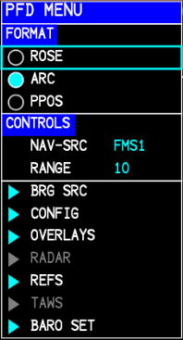

| **NOTE:** Items with a ▶ denote accessible sub-menus. |
| --- |

##### FORMAT

* **ROSE** - Changes the HSI to a 360° circular, compass rose.
* **ARC** - Changes the HSI to a 125° compass arc.
* **PPOS** - Present POSition. Centered on the aircraft with graphical route shown.

##### CONTROLS

* **NAV-SRC** - Allows for cycling of active navigation sources.
* **RANGE** - Set the map range displayed on the PFD and MFD.

**Fig 7.3 - PFD MENU**

| **NOTE**: Sub-menus in **DARK GREY** are not yet implemented. |
| --- |

##### ▶ **BRG SRC**

Bearing Source sub-menu (**Fig 7.4)** contains options to enable and configure 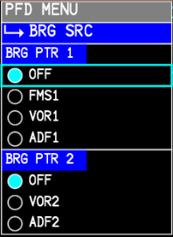**BRG PTR 1** (Bearing Pointer 1) and **BRG PTR 2** (Bearing Pointer 2) to display on both the PFD and MFD.

* **BRG PTR 1**
  + **OFF** - Hides BRG PTR 1.
  + **FMS1**- Sets pointer 1 to FMS1 active waypoint.
  + **VOR1**- Sets pointer 1 to VOR/LOC1 source.
  + **ADF1**- Sets pointer 1 to ADF1 station.
* **BRG PTR 2**
  + **OFF** - Hides BRG PTR 2.
  + **VOR2** - Sets Pointer 2 to VOR2/LOC2 source.
  + **ADF2** - **NOT MODELED**

**Fig 7.4 - BRG SRC**

##### ▶ **CONFIG**

Configuration sub-menu (**Fig 7.5)** contains general configuration options for the PFD.

* **PRESSURE** - Toggle between IN (in-Hg) or HPA (millibars).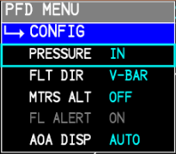
* **FLT DIR** - Changes the flight director bars to toggle between V-BAR and X-PTR type directors.
* **MTRS ALT** - When toggled ON, displays altitude in meters in a box above the altitude in feet on PFD. Also changes the altitude preselector to meters.
* **FL ALERT** - **NOT IMPLEMENTED**
* **AOA DISP** - Enables the PFD AOA to be toggled ON, OFF or AUTO. When AUTO is selected, the AOA will display when FLAPS are set to 35.

**Fig 7.5 - CONFIG**

| **NOTE**: Settings in the **CONFIG** menu will persist through each load when MSFS is exited properly through the menus. |
| --- |

#### TERR/WX

Terrain/Weather Button - Terrain/Weather. Cycles through display overlay on the HSI to either show terrain heights relative to the aircraft, or weather.

▶ **OVERLAYS** 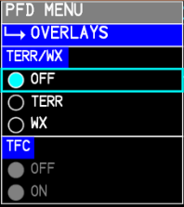

Overlays sub-menu (**Fig 7.6)** contains options for HSI overlay displays.

* **TERR/WX** -Terrain/Weather
  + **OFF** - Hides TERR/WX HSI overlays.
  + **TERR** - Displays relative terrain overlay on HSI.
  + **WX** - Displays weather overlay on HSI.
* **TFC** - Traffic
  + **OFF** - Hides traffic overlay.
  + **ON** - Shows traffic overlay.

**Fig 7.6 - OVERLAYS**

#### 

#### 

#### 

#### 

#### 

#### 

#### REFS MENU

References Button -Allows reference speeds, and minimums to be set or modified. V-speeds can be automatically sent to the **REFS** menu from the PERF page (TAKEOFF or APPROACH) in the FMS.

Speeds sent by the FMS will appear under the airspeed indicator in **MAGENTA** while any speed modified by the user will be **CYAN**.

##### ▶ REFS

References sub menu (**Fig 7.7**)**,** alsoaccessible from **PFD MENU** ↳**▶ REFS**.

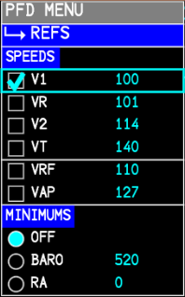

* **SPEEDS**
  + **V1** - Decision Speed
  + **VR** - Rotation Speed
  + **V2** - Takeoff Safety Speed
  + **VT** - Target Speed
  + **VRF** - Reference Speed
  + **VAP** - Approach Speed

| **NOTE:** If a speed is modified, it must be enabled with a **✔** before it will appear on the speed tape again. Use the **PUSH SELECT** on the highlighted value to enable. |
| --- |

* **MINIMUMS**
  + **OFF** - Hides minimums on PFD.
  + **BARO** - Show Barometric altimeter minimums on PFD.

Selectable from 0-14000ft.

* + **RA** - Show Radar Altimeter minimums - Sets minimums based on **Fig 7.7 - REFS**

the Radar Altimeter. Selectable from 0-2500ft.

| **RULE**: **The CJ4 is certified for ILS CAT I only!** BARO minimums *MUST* be used for all approaches. |
| --- |

#### BARO

Barometer Knob - Sets the altimeter display below the altitude indicator. Pressing the BARO knob will set the altimeter to **29.92 STD** (or **1013 STD** if using HPA).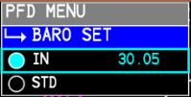

▶ **BARO SET**

Barometer Set sub-menu (**Fig 7.8),** accessible from **PFD MENU** ↳▶ **BARO SET** contains options to set the barometric pressure or enable STD (standard) altimeter setting. This is useful for preselecting a local altimeter setting while in STD mode. **Fig 7.8 - BARO SET**

#### ESC

Escape Button - Returns from sub-menu to parent menu or exits PFD MENU.

#### ET

Elapsed Time - Places a timer in the bottom-left corner of the PFD that counts up from zero seconds. Press ET once to begin. Once counting, press ET to stop. Once stopped, press ET to hide the timer.

#### FRMT

Format Button - Cycles the PFD HSI display between **ROSE**, **ARC**, or **PPOS** (*See* *PFD MENU* *above*).

#### TFC

#### Display or hide traffic on the PFD. The 12 “tick” marks around the inner ring correspond to the 12-hours on a clock and are used for traffic direction callouts *(See* *TCAS CONTROL* *under FMS for more information).*

| **NOTE:** To see traffic on the PFD when in ARC or ROSE mode, TERR or WX must be turned on. |
| --- |

#### 

#### Fig 7.1d - PFD TFC displayed and set to NORM.

**TILT** - **NOT IMPLEMENTED**

#### RANGE

Range Adjust Knob- The inner-right knob labeled **RANGE** controls the displayed map range for both the PFD and the MFD. **They are linked together** on both displays (this is how the real unit functions). Selectable range is 5NM to 600NM.

**THIS PAGE HAS BEEN INTENTIONALLY LEFT BLANK**

## 

## 

## 

## 

## 

## 

## 

## MFD - MULTI-FUNCTION DISPLAY

The Multi-Function Display (MFD) is capable of showing a number of parameters and is split into three (3) parts. The top window (outlined in yellow) contains engine and systems information. The UPPER window (outlined in red), displays other system information, FMS text, checklists, passenger briefings and CAS messages (*WIP*). The LOWER window (outlined in blue), displays maps and HSI formats. Other functions, such as charts, combine both the UPPER and LOWER windows of the MFD for better readability. All functions of the MFD are controlled via the CCP (Cursor Control Panel) below (*except map* *range* *and* *BRG pointers* *which are controlled from the DCP*).

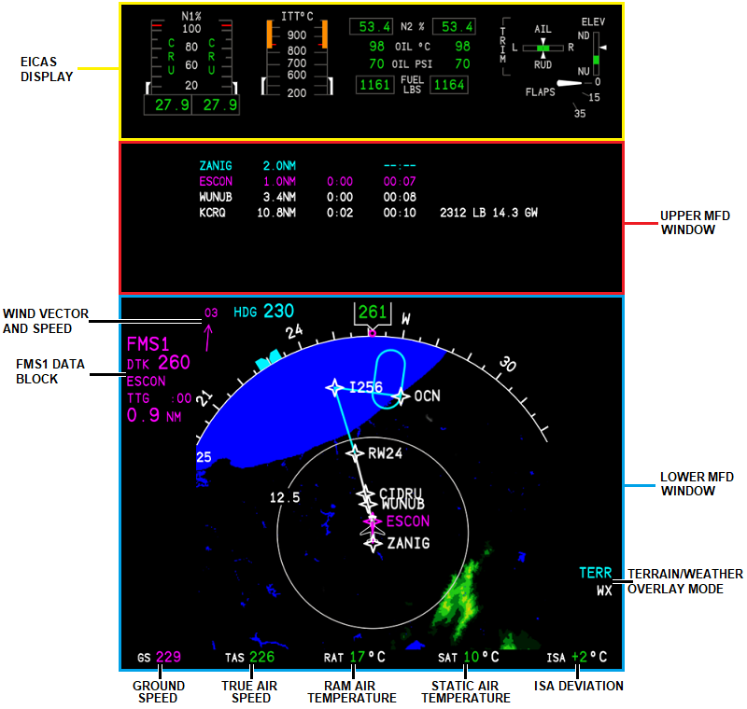

**Fig 7.9 - Multi-Function Display**

**THIS PAGE HAS BEEN INTENTIONALLY LEFT BLANK**

### CCP - CURSOR CONTROL PANEL

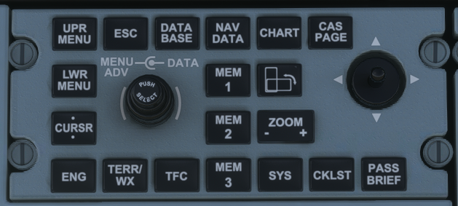

**Fig 7.10 - Cursor Control Panel**

The CCP (Cursor Control Panel) controls all display functions related to the Multi-Function Display (MFD).

**MENU ADV**

Menu Advance Knob - Operation the same as on the DCP. Allows the user to scroll through UPPER or LOWER MFD MENU options and data. Selected content will be outlined by a CYAN box.

|  | **DATA VALUE** |
| --- | --- |
|  | **DATA 123** |
| **◯** | **OPTION** |
| **⬤** | **OPTION** |
| ▶ | **SUBMENU** |

**DATA**

Data Knob - Allows data fields selected from the MENU ADV to be changed.

**PUSH SELECT**

Push Select Button - Used to enable/disable items highlighted with a 𐩒 or ⃞ toggle, or enter sub-menus, and make selections. Lists noted with a 𐩒 denote that only one option can be selected. Lists with a ⃞ denote that any number of items can be selected from the category. Once you scroll to the desired menu outlined in a cyan box, press the inner-middle button labeled **PUSH SELECT** to enter, enable, or disable.

#### UPR MENU

Upper MFD Menu Controls - Controls the data field displayed in the UPPER MFD WINDOW.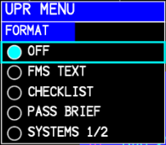

* **FORMAT**
  + **OFF** - Hides all UPPER MFD data (**Fig 7.12**).
  + **FMS TEXT** - Displays FMS Text data (**Fig 7.13**).
  + **CHECKLIST** - Displays a checklist on the MFD (**Fig 7.14**).
  + **PASS BRIEF** - Displays options for passenger audio briefings

to be played (**Fig 7.15)**.

* + **SYSTEMS 1/2** - Displays additional information about aircraft **Fig 7.11 - UPR MENU**

systems (**Fig 7.16**).

**Fig 7.12 - MFD UPPER** window **OFF** with **PPOS** mode selected.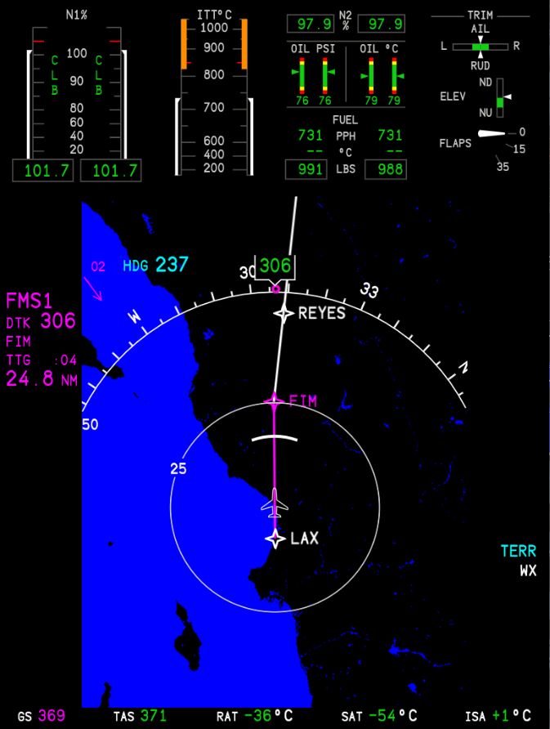

##### FMS TEXT

**Fig 7.13a - UPPER MFD FMS TEXT**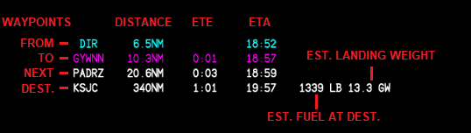

| **NOTE:** ETE format is H:MM. ETA format is HH:MM ZULU (UTC). They are calculated based on current Ground Speed. |
| --- |

**Fig 7.13b - FMS UPPER TEXT VNAV Window**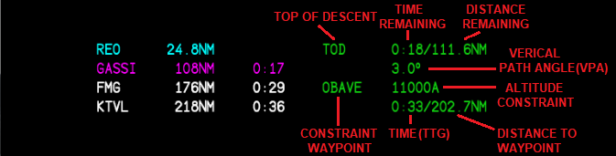

When the FMS text window is set to VNAV (*See* *DSPL MENU* *in FMS*), TOD and other VNAV descent parameters will appear in the FMS text window in place of ETA, fuel at destination, and landing weight. TOD and descent information will only appear if a STAR or approach has been selected and populated with altitude restrictions, otherwise you will receive an advisory descent (see below). VNAV will follow this descent mode if the information described above is entered.

**Fig 7.13c - UPPER MFD FMS TEXT VNAV ADVISORY**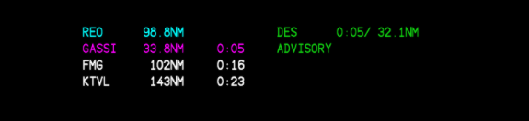

An Advisory Descent appears when no altitude constraints (no STAR or approach loaded) are present between the enroute portion of the flight and the destination. DES ADVISORY will provide an advisory point (DES) to begin a descent that will put you at 1500’ AFE (above field elevation), 10nm from the destination airport. CRZ ALT in PERF INIT must be filled in for the advisory descent to calculate. Advisory descents will NOT follow a VNAV path if armed. They must be manually controlled by the pilot.

##### CHECKLIST

##### Fig 7.14 - UPPER MFD CHECKLIST

##### PASS BRIEF

**Fig 7.15 - UPPER MFD PASSENGER BRIEFING**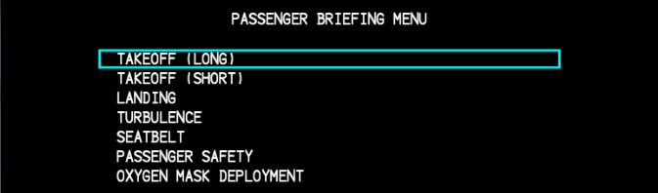

##### SYSTEMS 1/2

**Fig 7.16 - SYSTEMS 1/2**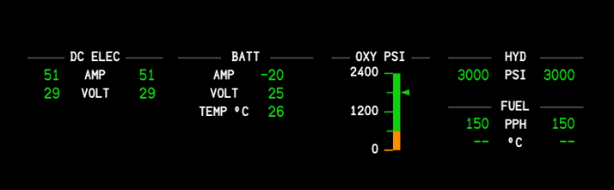

#### 

#### 

#### 

#### 

#### 

#### 

#### 

#### LWR MENU

Lower MFD Menu Controls (**Fig 7.17**) - Controls the data field displayed in the LOWER MFD WINDOW.

##### FORMAT

* + **ROSE** - Changes the HSI to a 360° circular, compass rose.
  + **ARC** - Changes the HSI to a 125° compass arc.
  + **PPOS** - Present POSition. Centered on the aircraft with graphical route shown.
  + **PLAN** - Centers on a waypoint showing North (N) up.
  + **GWX** - **NOT IMPLEMENTED**
  + **TCAS** - **NOT IMPLEMENTED**

| **NOTE:** The PLAN view will initially stay centered and follow the aircraft if waypoints have not been ‘stepped’ through (*See* *MFD ADV*). Once you step through a waypoint, it cannot be re-centered on the aircraft. The real unit does not center on the aircraft. |
| --- |

##### CONTROLS

##### **MAP-SRC** - Always FMS1 on the MFD. Cannot be changed.

**Fig 7.17 - LWR MENU**

##### ▶ **OVERLAYS**

Overlays sub-menu (**Fig 7.18**)contains options for HSI overlay displays.

* **TERR/WX** -Terrain/Weather
  + **OFF** - Hides TERR/WX HSI overlays.
  + **TERR** - Displays relative terrain overlay on HSI.
  + **WX** - Displays weather overlay on HSI.
* **TFC** - Traffic - **NOT IMPLEMENTED**
  + **OFF** - Hides traffic overlay.
  + **ON** - Shows traffic overlay. **Fig 7.18 - OVERLAYS**

##### 

##### 

##### 

##### 

##### 

##### 

##### 

##### ▶ MAP SYMBOLS

Map Symbols sub-menu (**Fig 7.19**). Show or hide map symbols on the MFD. Symbols will be displayed when they are selected with a **✔**.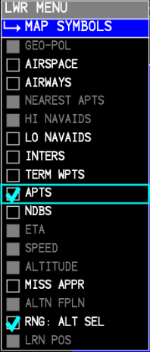

* **AIRSPACE** - **DISABLED**
* **AIRWAYS** - **DISABLED**
* **LO NAVAIDS** - Show both HIGH and LOW VORs.
* **INTERS** - Show intersections.
* **APTS** - Show airports.
* **NDBS** - Show NDBs.
* **MISS APPR** - Show Missed Approach procedure (in cyan).
* **RNG: ALT SEL** - Shows the altitude “banana.”

| **NOTE**: Many MAP SYMBOLS can also be displayed using the DSPL MENU key of the FMS. |
| --- |

**Fig 7.19 - MAP SYMBOLS**

**MFD** with symbols.

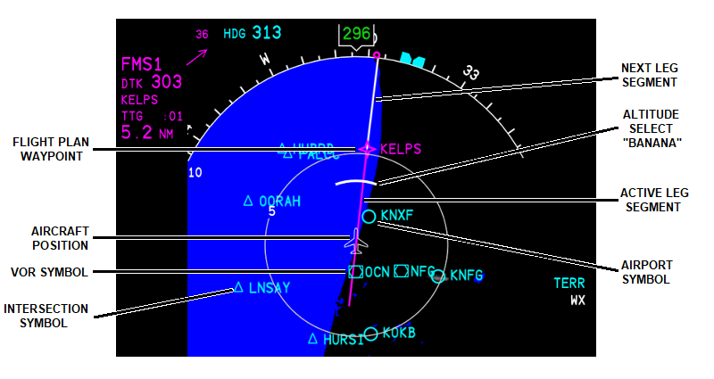

##### ▶ SYS TEST - NOT IMPLEMENTED

**CURSOR** - **NOT IMPLEMENTED**

#### ENG

Engine Button - Show or hide the EICAS display above the UPPER MFD WINDOW.

#### ESC

Escape Button - Closes out the current sub-menu or parent menu on the UPPER or LOWER MFD MENU.

#### TERR/WX

Terrain/Weather Button- Show or hide the weather or terrain overlays on the MFD.

#### TFC

#### Display or hide traffic on the MFD. The 12 “tick” marks around the inner ring correspond to the 12-hours on a clock and are used for traffic direction callouts *(See* *TCAS CONTROL* *under FMS for more information).*

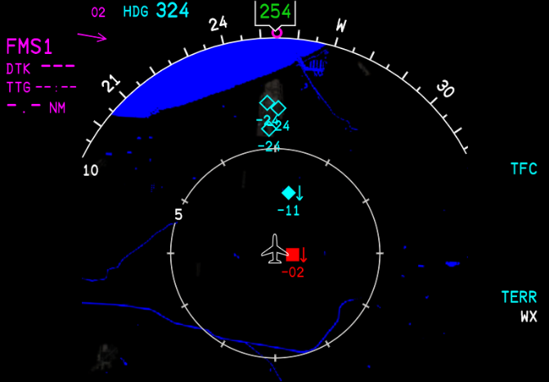

**DATA BASE** - **NOT IMPLEMENTED**

**NAV DATA** - **NOT IMPLEMENTED**

#### **MEM1, MEM2, MEM3**

Memory 1, 2, and 3 Buttons - Allows the user to save MFD configuration states into one (1) of three (3) recallable memory banks. To save MFD states to memory, set the MFD layout configuration to a state which you would like to save. Then, press and hold the corresponding memory (MEM 1, 2 or 3) key for three (3) or more seconds and then release. The configuration should now be stored and can be recalled by pressing the corresponding **MEM** key to which it was saved. There is no confirmation message.

| **NOTE:** The memory store function will store parameters such as overlays (TERR/WX,TFC), and LOWER MFD window options such as displayed airports or navaids. |
| --- |

| **NOTE:** Only combinations of the UPPER and LOWER MFD windows can be stored. Full screen configurations and charts cannot be stored. |
| --- |

#### CHART

Show or hide Electronic Charts - ***REQUIRES NAVIGRAPH CHART SUBSCRIPTION***. Charts may be geo-referenced to the aircraft’s position where available (*See* *E-Charts*).

**CHART ORIENTATION** - **NOT IMPLEMENTED**

#### ZOOM - +

Chart Zoom - Zooms the selected chart in or out. The selected chart will scale automatically to fit the width of the display if it is longer than it is wide. Pressing the ZOOM button once will zoom the chart in from the center. Pressing it a second time will zoom it back out to the default level. The maximum zoom level for charts is 2x.

#### JOYSTICK

Chart display joystick - Slews the view around the chart when zoomed in.

#### 

#### SYS

Systems Button - Show or hide the systems overlay on the LOWER MFD window.

**Fig 7.20a - Systems 1/2**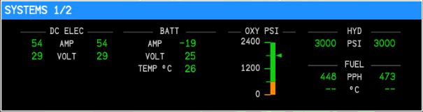

**Fig 7.20b - Systems 2/2**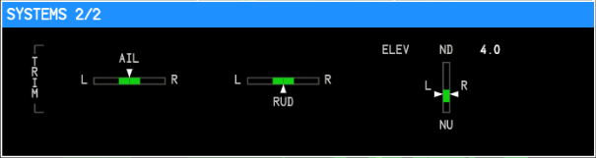

#### 

#### **CAS PAGE**

Crew Alert System Button - **NOT IMPLEMENTED**

#### CKLST

Checklist Button - Displays the checklist menu in the UPPER MFD window. Will overwrite any current displays. To reset the checklists, hit the ESC button until you are back to the CHECKLIST INDEX, then scroll down to RESET CHECKLIST and select using the PUSH SELECT button on the CCP.

#### PASS BRIEF

Passenger Briefing Button - Displays the passenger briefing audio menu in the UPPER MFD window. Like the CKLST button, this will overwrite any menus currently displayed.

### 

### 

### ~~ELECTRONIC CHARTS (E-CHARTS)~~

~~Electronic charts (E-Charts) are displayed on the UPPER and LOWER MFD.~~ ***~~REQUIRES NAVIGRAPH CHART SUBSCRIPTION.~~*** ~~After a valid Navigraph account has been linked (~~*~~See~~* *~~MOD SET~~* *~~in the FMS section above~~*~~), the charts will be available by pressing the CHART button. Before any charts will appear, an ORIGIN and/or DEST (destination) must be filled on the FPLN page. Then, press the LWR MENU button and use the MENU ADV (outer knob) on the CCP to highlight a chart. To view, press the inner PUSH SELECT button. If a departure, arrival, or approach for the origin and/or destination airports has been selected, the corresponding charts will automatically populate into the CHART MAIN INDEX (~~**~~Fig 7.25a~~**~~). Press the ESC key to return to the chart on the MFD. (~~*~~For night chart mode, see~~* *~~PANEL~~* *~~lighting.~~*~~)~~

**~~Fig 7.25a - Chart Main Index~~**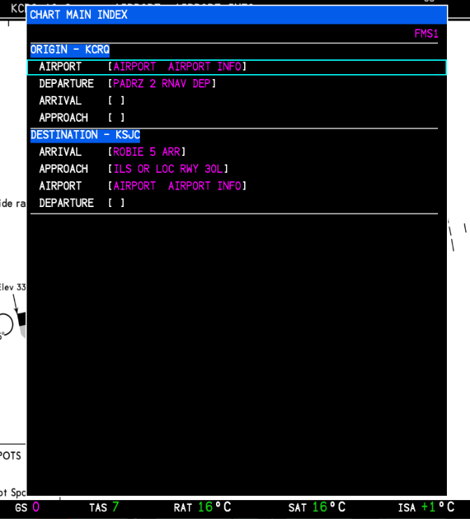

**~~SELECTING A NEW CHART~~**

~~If a field has not been auto-populated, because a departure, arrival or approach has not been selected, highlight the blank field ([ ]) after AIRPORT, DEPARTURE, ARRIVAL, or APPROACH and press PUSH SELECT to bring up a list of all the procedures for that index. If a chart index is already populated, you can long-press the PUSH SELECT button on any populated field to view all available procedures under that index. Use the ESC key to return to the INDEX menu.~~

**~~Fig 7.25b - Chart APPROACH Index~~**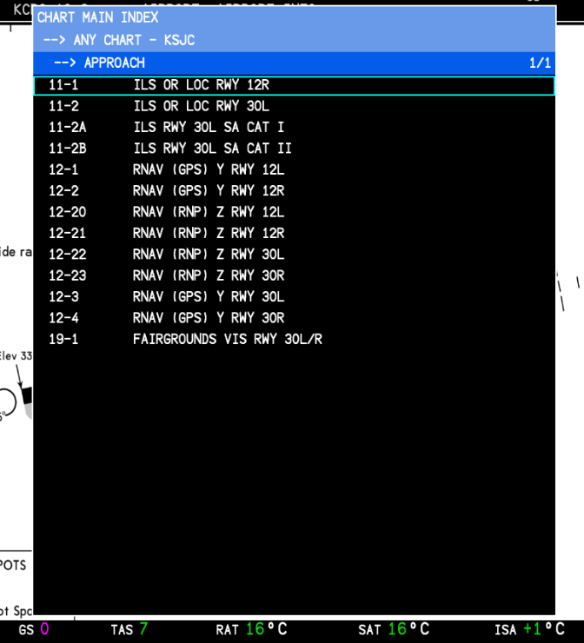

~~The CJ4 will geo-reference the aircraft’s position and superimpose it over the chart (if applicable). The aircraft’s present position, with north pointing up, will show as a pink aircraft symbol. To hide the charts and return to the HSI and/or UPPER window, press the CHART button while the chart is displayed. With a chart displayed (~~**~~Fig 7.25c~~**~~), you can scroll through all selected charts populated in the MAIN CHART INDEX by using the MFD ADV knob on the CCP.~~

**Fig 7.25c - Geo-referenced aircraft position**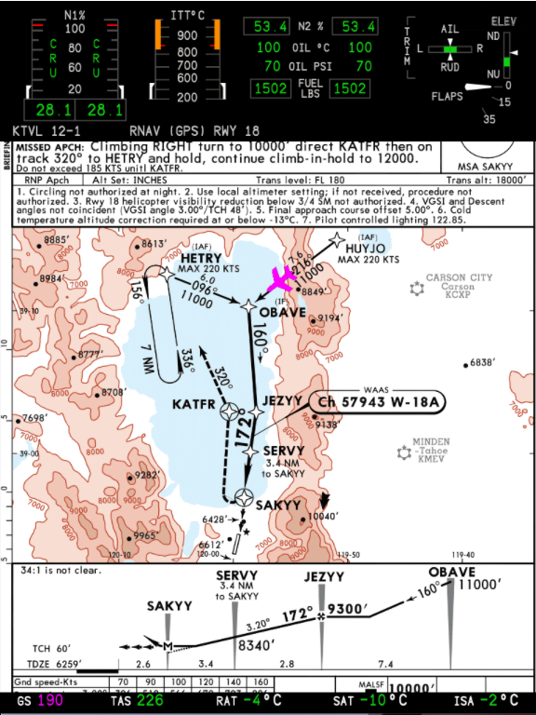

**THIS PAGE HAS BEEN INTENTIONALLY LEFT BLANK**

## 

## 

## 

## 

## 

## 

## 

## PFD/MFD - MAP MODES

The PFD and MFD have a number of map modes common to both displays such as ARC, ROSE and PPOS. PLAN mode can only be displayed on the MFD. Both the PFD and MFD are nearly identical with the exception of one feature. The MFD active waypoint data block will also include TTG (Time To Go - in minutes) below the waypoint identifier while the PFD will not include this.

### ROSE

Displays a 360 degree compass rose.

#### PFD ROSE

#### Fig 7.30a - PFD ROSE

#### MFD ROSE

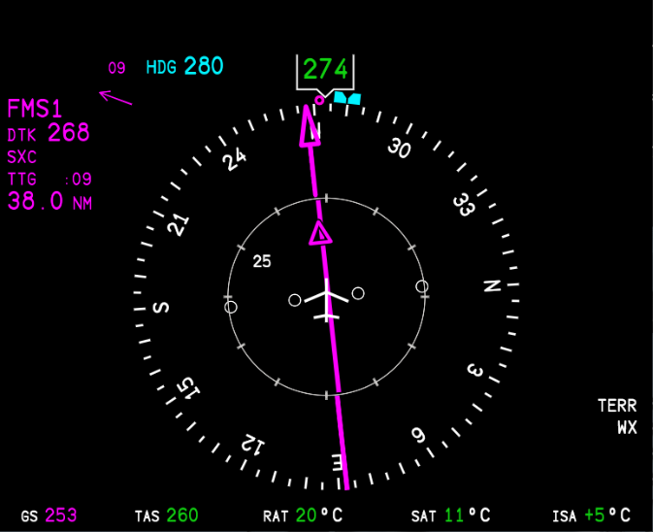

**Fig 7.30b - MFD ROSE**

### ARC

Displays a 125 degree arc. TTG is also displayed on the MFD ARC.

#### PFD ARC

**Fig 7.31a - PFD ARC** 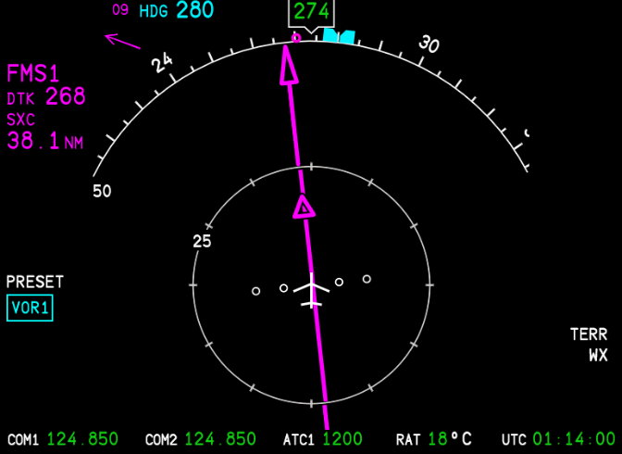

#### MFD ARC

**Fig 7.31b - MFD ARC**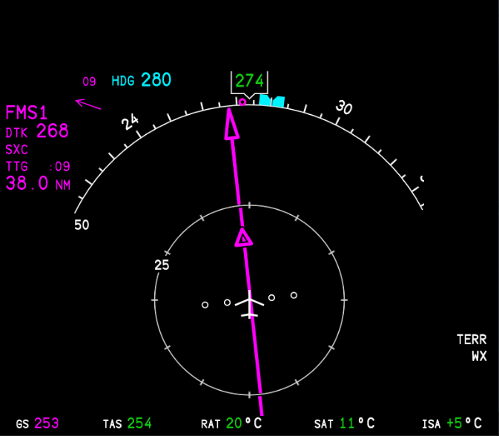

### PPOS

Centers and follows the aircraft showing heading up, and displays route map with waypoints. Displaying PPOS on the PFD only will also enable a lateral deviation line to appear below the attitude indicator.

#### PFD PPOS

### Fig 7.32a - PFD PPOS

#### MFD PPOS

**Fig 7.32b - MFD PPOS**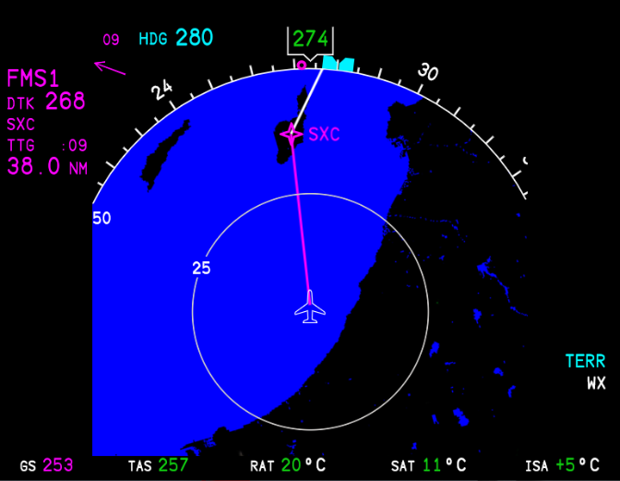

### PLAN

Centers on a waypoint showing NORTH (N) up and allows for a flight plan to be previewed using the MFD ADV function (*see* *MFD ADV* *above*).

| **NOTE:** The PLAN view will initially stay centered and follow the aircraft if waypoints have not been ‘stepped’ through (*See* *MFD ADV*). Once you step through a waypoint, it cannot be re-centered on the aircraft. The real unit never tracks and centers the PLAN view on the aircraft. |
| --- |

**Fig 7.33 - MFD PLAN**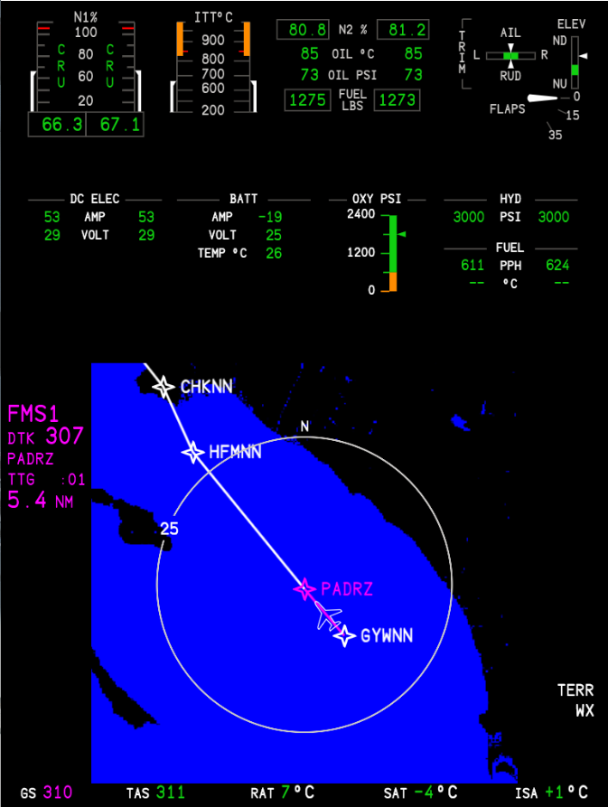

**THIS PAGE HAS BEEN INTENTIONALLY LEFT BLANK**

# 8 - SYSTEMS

## AUDIO CONTROL PANEL - ACP

**Fig 8.1 - Audio Panel**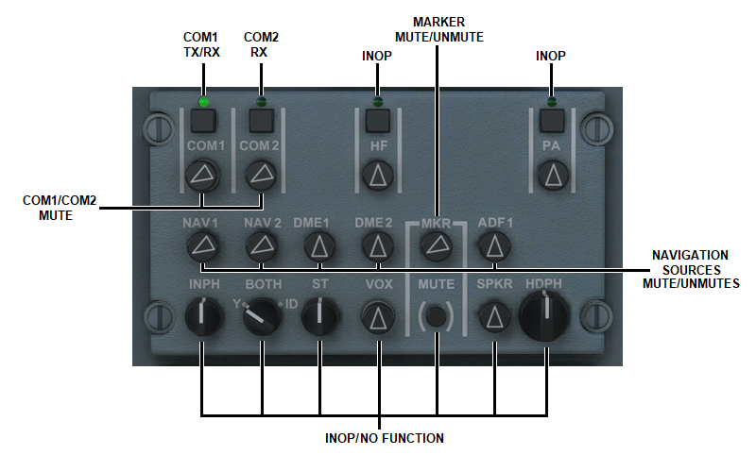

### COM 1/2

Both COM1 and COM2 are capable of transmitting and receiving. The square button above the label toggles which radio is the active transmit source. A green light above the switch indicates which source you are currently transmitting on. The round knobs below the radio label mute and unmute that radio. The buttons modeled in the MSFS CJ4 vary slightly from the real aircraft. In the MSFS version, there is no way to push the knobs in or out. Also unlike the real aircraft, in MSFS, when the knob is pointed all the way to the left (ie. COM1), the radio is set to MAX volume. When the radio knob is pointing straight up (ie. DME1), the radio is MUTED. In the image above (**Fig 8.1)**, COM1 is set to transmit (TX) and receive (RX) while COM2 is currently set to receive (RX) only. You can only transmit on one (1) radio at a time while you can receive on both. This is useful for talking on one radio while monitoring the other for ATC or ATIS information.

| **NOTE:** In the current configuration, you can MUTE the radio you are transmitting on. Be sure to check the position of the knob or cockpit tooltip if no audio is being received. |
| --- |

### NAVIGATION SOURCES

All other buttons are currently inoperable with the exception of MARKER. Toggle the knob under MKR to mute or unmute ILS marker beacon tones.

| **NOTE**: The cockpit tooltips will show the button state when TOGGLED, not the present button state. |
| --- |

## 

## 

## 

## 

## 

## 

## 

## 

## 

## 

## 

## 

## 

## 

## ELECTRICAL PANEL

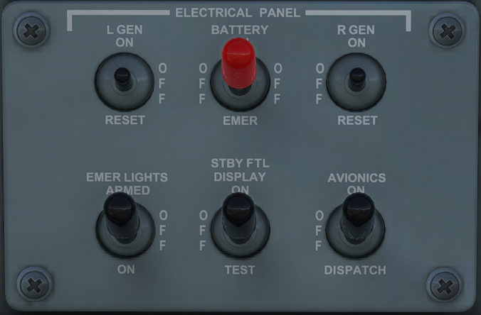

**Fig 8.2 - Electrical Panel**

#### L/R GEN

Left and Right Generators - Provides power from the left and right generators to the main electrical bus. Generator switches should both be placed into the ON position as per the Cockpit Preparation checklist.

#### BATTERY

Battery Master Switch - The battery master switch supplies main electrical power to the aircraft.

#### EMER LIGHTS

Emergency Lights - The emergency lights provide power to interior lights (and wing escape lights in the event of an evacuation) when DC power fails. The switch should be in the ARMED position as per the checklist or you will receive a CAS alert displaying EMER LIGHTS NOT ARMED.

| **NOTE:** Emergency lighting is not currently modeled in the sim but the CAS system does read the switch position. |
| --- |

#### STBY FLT DISPLAY

Standby Flight Display - Turns the standby flight display between the MFD 1 and MFD 2 on or off.

#### AVIONICS

Avionics Switch - Controls power to the avionics systems. When the avionics switch is set to the ON position, all avionics systems are powered on for normal operation. When the switch is set to DISPATCH, only the left MFD and left FMS will be active. The TUNE page of the FMS will also be in a DISPATCH mode which only allows for COM1/NAV1 operation (*See* *DISPATCH* *page in FMS for more information*).

## LIGHTING PANEL

The lighting panel controls both the interior cockpit and exterior lighting as well as screen dimming options for the left and right PFDs and MFDs.

**Fig 8.3 - Lighting Panel**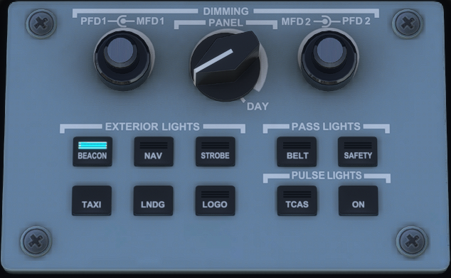

### DIMMING

#### PFD1/2

PFD1/2 Dimming Knob - The outer, larger knob controls the screen brightness for the Primary Flight Displays. PFD1 is the left, pilot-side PFD. PFD2 is the right, co-pilot-side PFD. Brightness operates independently.

#### MFD1/2

MFD1/2 Dimming Knob - The inner, smaller knob controls the screen brightness for the Multi Function Displays. MFD1 is the left, pilot-side MFD. MFD2 is the right, co-pilot-side MFD. Brightness operates independently.

#### PANEL

Panel Dimming Knob - The panel dimming knob controls the backlighting for the instrument panels in the cockpit. When the switch is set all the way to the right, on DAY, panel lighting will be off and “day-mode” charts will be displayed. When the switch is moved one position to the left (when panel backlighting illuminates) charts will then be in “night-mode.” Turning the knob to the left will dim the panel backlighting while keeping the charts in “dark mode.” When the switch is moved from a “day-chart” setting to a “night chart” setting, the chart should now automatically switch to the correct mode based on the knob position.

### EXTERIOR LIGHTS

#### BEACON

Controls the beacon light located on the top of the vertical stabilizer. Should be in the ON position prior to engine start.

#### NAV

Controls the navigation lights. A red light is found on the tip of the left wing and a green light is found on the tip of the right wing. In addition, each wing-tip has a rear-facing LED position light. They are typically left on at all times.

#### STROBE

Controls the anti-collision lights found on the wingtips between the navigation lights and the position lights. Typically turned on at all times when entering an active runway for crossing, or for takeoff. Left on until exiting the runway after landing.

#### TAXI

Turns the forward-facing, LED lights on the underside of the aircraft to the normal illumination setting. The taxi lights and the landing lights are the same set of lights but set to different intensities.

#### LNDG

Turns the forward-facing, LED lights on the underside of the aircraft to the highest illumination setting for greatest visibility. Most commonly used for takeoff and landing, and when below 10,000’ during day or night operations.

#### LOGO

Turns the tail logo lights on or off. Generally used at night from engine startup to engine shutdown.

### PASS LIGHTS

| **NOTE:** These light switches currently have no effect on modeled interior lighting in MSFS. |
| --- |

#### SAFETY

When the SAFETY switch light is activated, a safety message is played over the PA. On the real aircraft the SEAT BELT, NO SMOKING, and all emergency EXIT signs are illuminated.

#### BELT

When the BELT sign is activated, a seatbelt message is played over the PA. On the real aircraft, the SEAT BELT ON sign is illuminated while all emergency EXIT signs are turned off.

### PULSE LIGHTS

#### ON

The pulse light system pulses the landing lights for greater visibility. When set to the ON position this will override the landing lights steady illumination. The pulse light system must be OFF for all night ground operations and night flight operations below 300ft AGL.

**TCAS**

**NOT IMPLEMENTED**

## STANDBY ATTITUDE INDICATOR

The Standby Attitude Indicator (SAI), provides an independent display for critical flight information in the event of a primary system failure.

**Fig 8.5a - SAI on the ground.** **Fig 8.5b - SAI in flight.**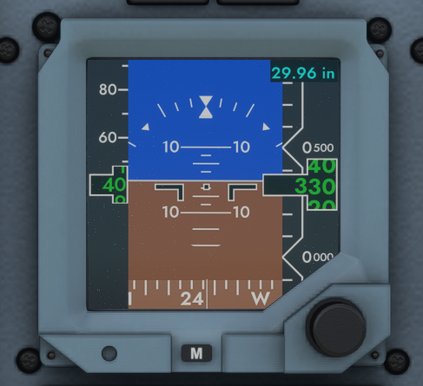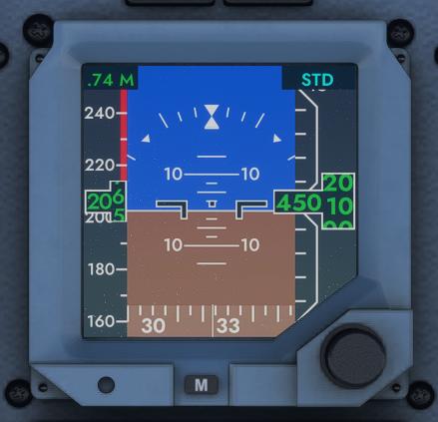

| **NOTE:** The BARO set knob on the SAI acts independently from the one on the DCP however, as a result of simulation modeling, there is currently no way to “press” the knob like in the actual unit. As a work around, the STD setting is tied to the STD “press” on the DCP. |
| --- |